PROJECT TITLE: FARM MANAGEMENT SYSTEM

User Story:
As a Farm Manager, I want to use the Farm Management System to maintain and manage farmer, farm, crop, buyer, and transaction information in a centralized Salesforce platform, so that I can easily access accurate agricultural records and efficiently monitor farm-related activities.
The system should allow me to create, view, update, and manage records through a simple and user-friendly interface. It should provide data validation to reduce incorrect entries, reports and dashboards to analyze important information, and appropriate access controls to protect the stored data.
By using this system, I can reduce manual paperwork, minimize data errors, save time, and manage agricultural information in an organized and efficient manner.

1. INTRODUCTION

1.1 Project Overview :

The Farm Management System (FMS) is a Salesforce-based application developed to manage farm-related information in one centralized platform. It helps users maintain details about farmers, farms, crops, buyers, and transactions.

The system allows users to add, view, and update records easily. It also uses validation rules, reports, dashboards, and security features to improve data accuracy and management.

The main aim of the project is to reduce manual work, organize agricultural data, save time, and provide easy access to important farm information.

1.2 Purpose :

The main purpose of this project is :

The purpose of the Farm Management System is to provide a centralized platform for managing and organizing farm-related information. The system helps maintain details about farmers, crops, and buyers in a structured manner. It also supports efficient record management, reporting, and monitoring of farm activities, helping users access important information easily and manage agricultural data effectively.

2. IDEATION PHASE
2.1 Problem Statement (Customer Problem Statement Template)

PS | I am  (Customer) | I’m trying to | But | Because | Which makes me  feel
PS-1 | Farmer | Maintain farm and crop records | Data is often incomplete or incorrect | Records are kept manually in registers | Frustrated and confused
PS-2 | Farm Manager | Monitor farm productivity and sales | Reports are delayed and inaccurate | Data is scattered across files and sheets | Stressed and inefficient
PS-3 | Buyer | Access crop availability and pricing | Information is not updated regularly | There is no centralized digital system | Uncertain and dissatisfied
PS-4 | System Admin | Manage user access and system security | Unauthorize d access may occur | Access  control is handled manually | Concerned and insecure

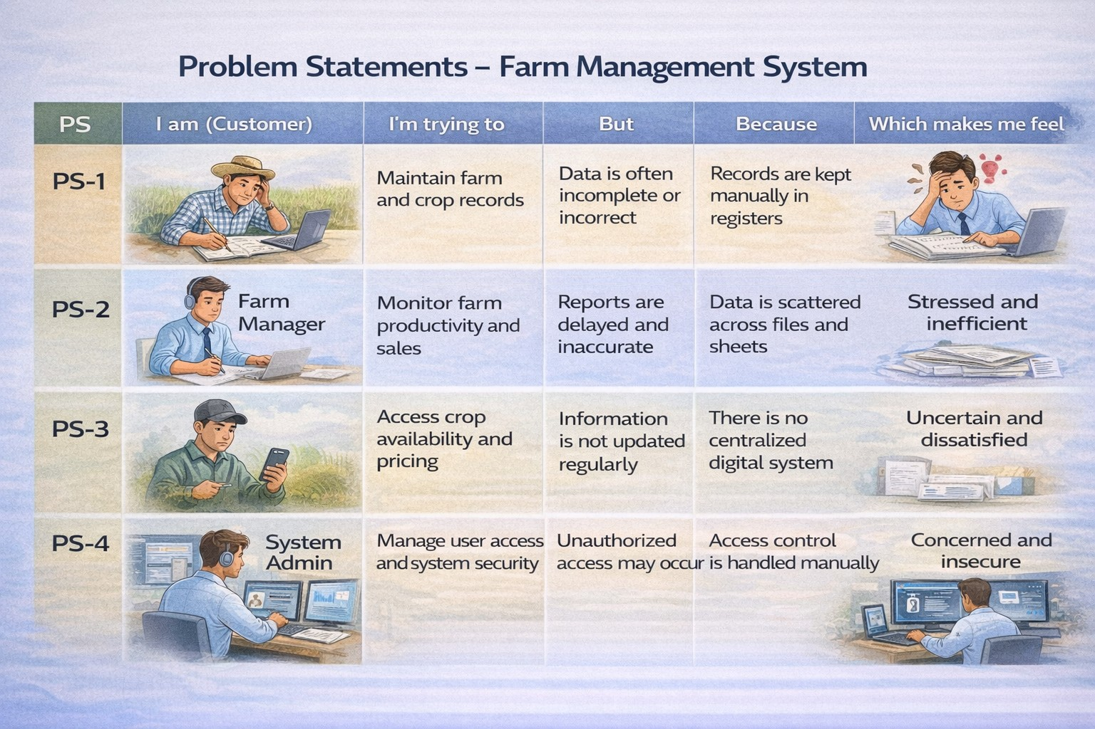

2.2 Empathy Map Canvas
Target Users:
- Farmers
- Farm Managers
- Buyers
- System Administrators

Empathy Analysis
- Think & Feel: Wants to manage farm information easily, reduce paperwork, and keep farmer, crop, and buyer details organized.

- Hear: Hears about the need for better digital record management, accurate information, and efficient farm administration.

- See: Sees scattered records, manual data entry, difficulty finding information, and the need for a centralized system.

- Say & Do:

Says that managing records manually takes time and tries to maintain farmer, crop, and buyer details systematically.

- Pain: Difficulty maintaining records, time-consuming data management, difficulty accessing information quickly, and challenges in preparing reports.

- Gain: Organized records, faster access to information, easier management of farmer/crop/buyer data, and useful reports for monitoring.
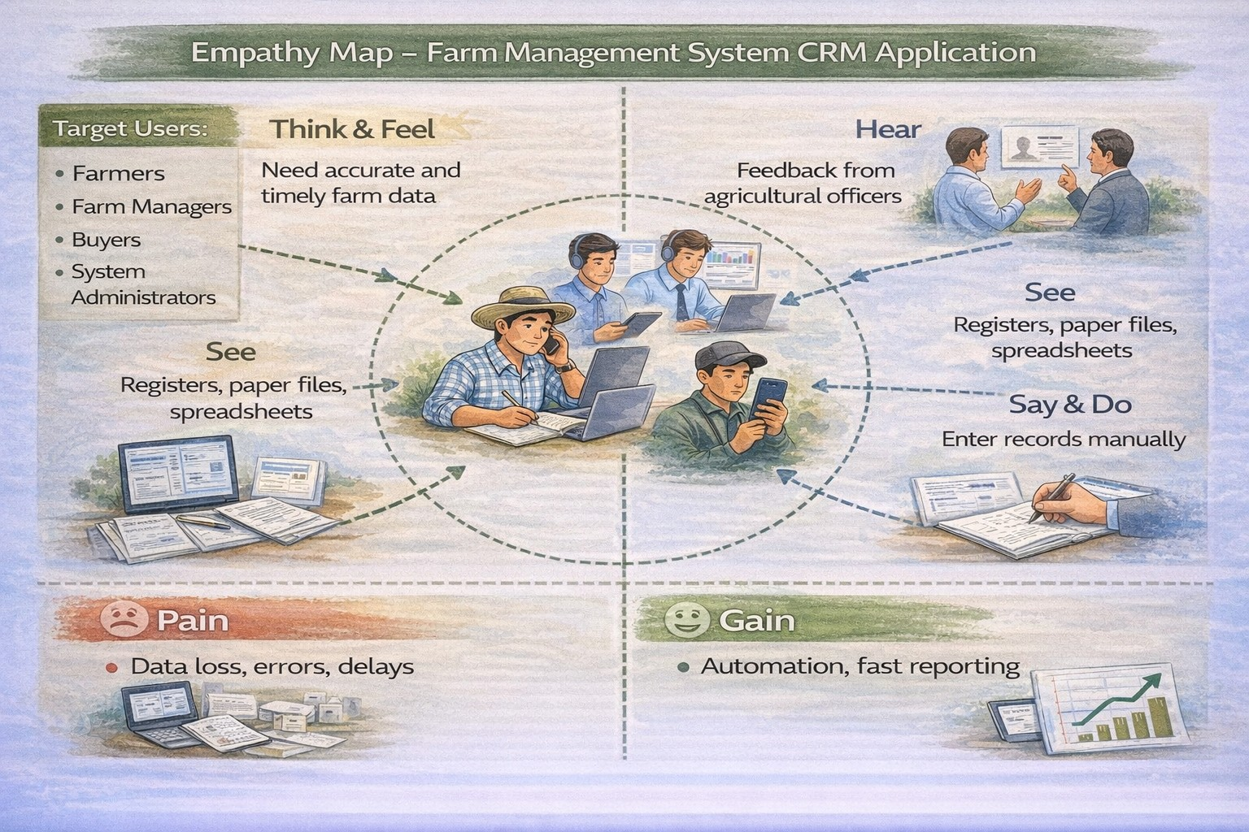

2.3 Brainstorming

Brainstormed Ideas

Create a centralized system to store farmer information.

Maintain crop details such as crop type, planting, harvesting, irrigation, and yield information.

Maintain buyer details and their requirements.

Connect farmer, crop, and buyer information for easier management.

Provide reports to view and monitor farm-related records.

Use dashboards and charts to present important information clearly.

Reduce manual paperwork and duplicate data entry.

Provide a simple and user-friendly interface for managing records.

Store farm information securely in a centralized cloud-based platform.

Provide scope for future features such as notifications, weather information, and crop recommendations.

Selected Idea
Salesforce-based Farm Management System.

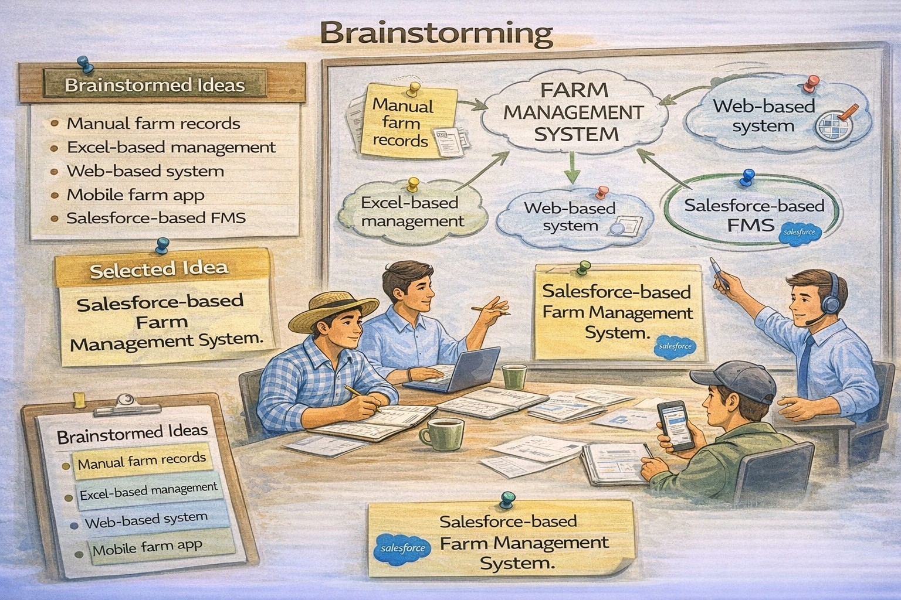

3.REQUIREMENT ANALYSIS PHASE

3.1 Customer Journey Map
Stages:
- Login
- Access Farm Management App
- Enter Farm and Crop Data
- Register Farmers and Buyers
- Generate Reports
- Analyze Results
- Decision Making

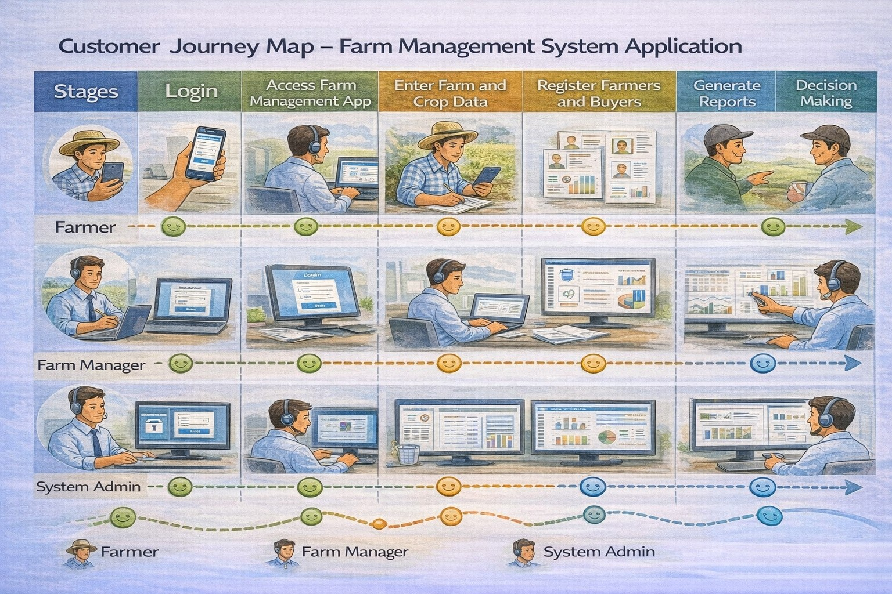

3.2 Solution Requirements

Functional Requirements

FR No | Requirement
FR-1 | User Authentication
FR-2 | Farm, Crop, Farmer, Buyer Management
FR-3 | Data Entry and Validation
FR-4 | Relationship Mapping
FR-5 | Report Generation
FR-6 | Dashboard Visualization
FR-7 | User Role Management

Non-Functional Requirements

NFR | Description | Example
Usability | Easy interface | Simple Lightning UI
Security | Data protection | Profiles & roles
Reliability | No data loss | Cloud backup
Performance | Fast access | Reports in <3 sec
Availability | 24/7 access | Cloud hosting
Scalability | Handles growth | More farms/users

3.3 Data Flow Diagram
Data Flow:
User → Salesforce UI → Custom Objects (Farm, Crop, Farmer, Buyer) → Validation
Rules → Relationships → Reports → Dashboards
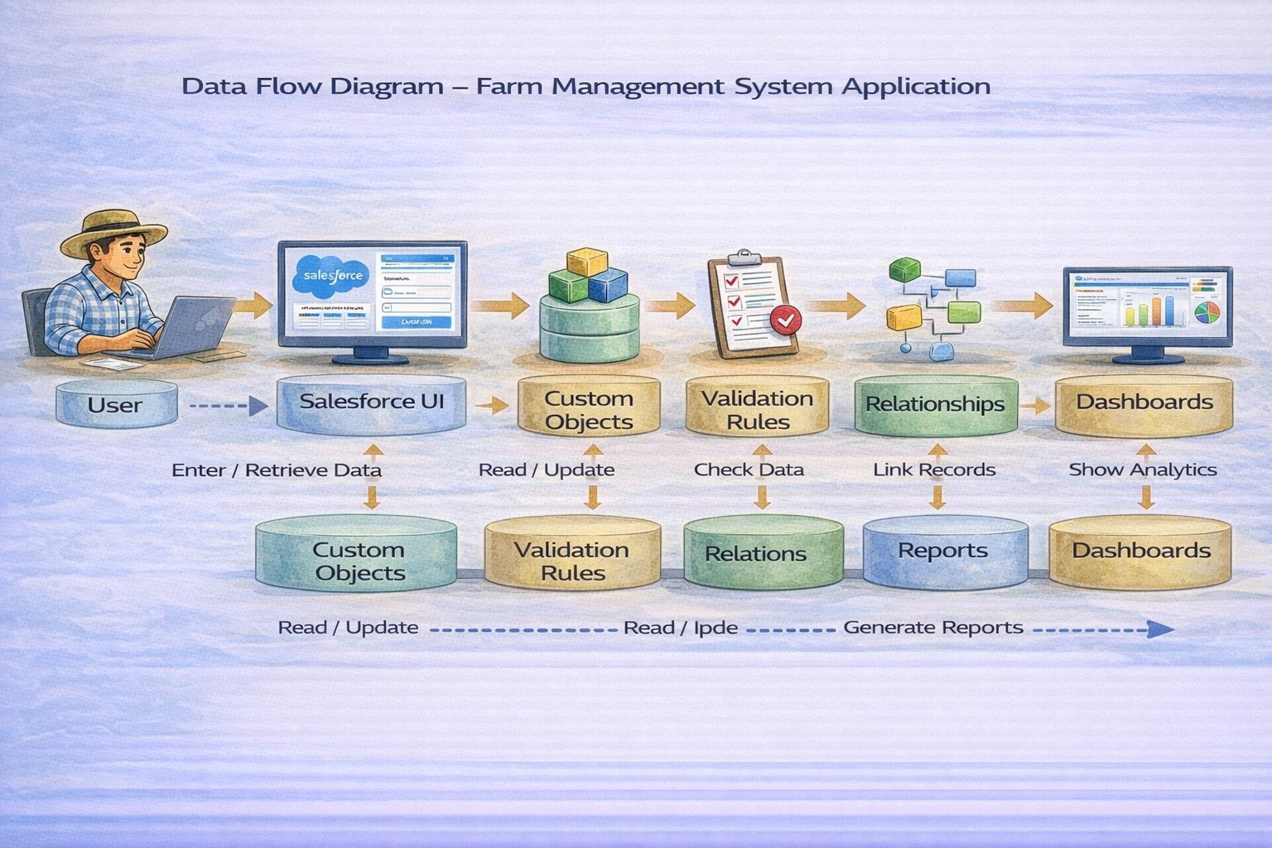

3.4 Technology Stack
Layer | Technology
Frontend | Salesforce Lightning UI
Backend | Salesforce Platform
Database | Salesforce Cloud
Automation | Validation Rules
Analytics | Reports & Dashboards

4. PROJECT DESIGN PHASE

4.1 Problem–Solution Fit
The FMS replaces manual farming records with automated data management. Cloud storage prevents data loss, dashboards improve analysis, and real-time reports eliminate delays. This ensures accurate and timely agricultural insights.
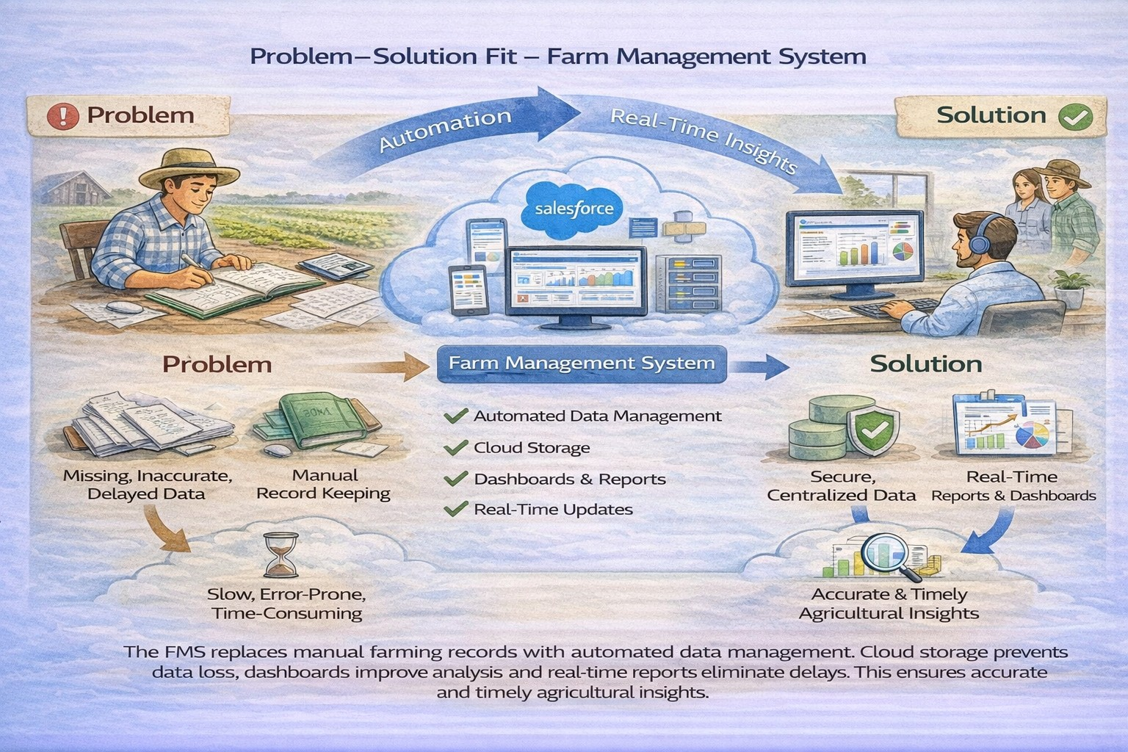

4.2 Proposed Solution

Functional Requirements
Parameter | Description
Problem | Manual maintenance of farm, crop, farmer, and buyer records leading to errors, data loss, and delays.
Solution | Salesforce-based Farm Management System with centralized data storage and automation.
Innovation | Automated data entry validation, cloud storage, and real-time reporting dashboards.
Impact | Improved data accuracy, faster reporting, and better decision-making for farmers and managers.es
Business Model | Digital farm management and agricultural data services platform.
Scalability | Supports multiple farms, users, and regions with cloud-based infrastructure.

4.3 Solution Architecture

Architecture Layers
- Presentation Layer – Salesforce Lightning UI
- Application Layer – Validation Rules, Relationships
- Data Layer – Custom Objects
- Analytics Layer – Reports and Dashboards

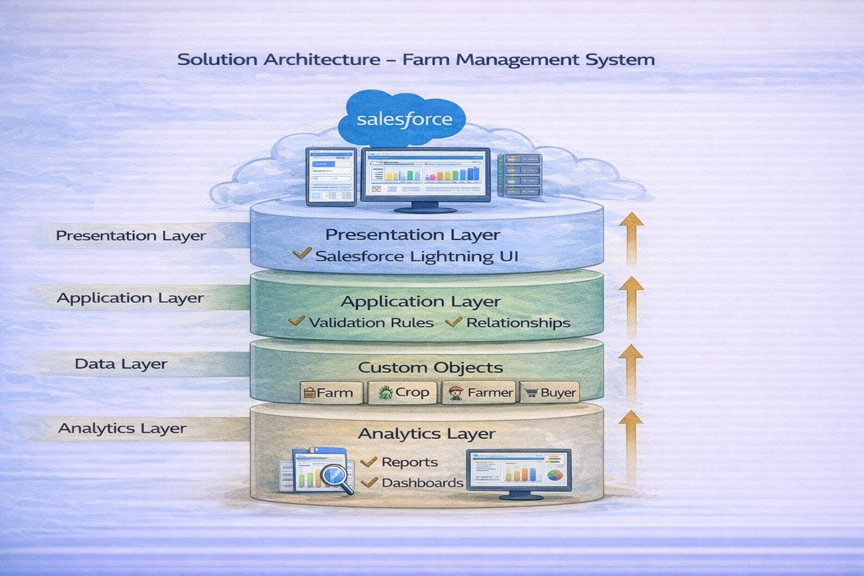

5. PROJECT PLANNING & SCHEDULING
5.1 Project Planning
- Created Salesforce Developer Org
- Developed custom objects
- Configured tabs and Lightning App
- Created fields and relationships
- Designed profiles and roles
- Created users and sharing rules
- Developed reports and dashboards
- Conducted testing and reviews

Product Backlog, Sprint Schedule, and Estimation (4 Marks)
Use the below template to create product backlog and sprint schedule

Sprint | Functional  Requirement  (Epic) | User  Story  Number | User Story / Task | Story Points | Priority | Team Member  s
Sprint-1 | Developer Setup | USN-1 | As a system administrator, I want to create and configure a  Salesforce developer account so that I can set up and deploy the Farm Management System. | 3 | High | Member1
Sprint-2a | Data Modeling | USN-2 | As an admin, I want to create Farm, Crop, Farmer, and Buyer objects with proper relationships so that agricultural data is stored and managed efficiently. | 5 | High | Member2
Sprint-2 | Data Modeling | USN-3 | As a staff member, I want tabs and a Lightning App for all farm modules so that I can easily navigate and perform daily operations. | 5 | High | Member3
Sprint-3 | Automation | USN-4 | As a system, I want to validate farm and crop details such as dates, quantities, and mandatory fields so that incorrect or incomplete records are prevented. | 3 | High | Member4
Sprint-3 | Automation | USN-5 | As a manager, I want automated flows for crop updates and buyer notifications so that farm operations are processed faster without manual intervention. | 3 | High | Member4
Sprint-4 | Security | USN-6 | As an administrator, I want role-based access control for farmers, managers, and buyers so that sensitive farm and transaction data is secure. | 5 | High | Member2
Sprint-5 | Reports | USN-7 | As a farm manager, I want reports showing crop yield, sales, and buyer transactions so that I can monitor farm performance and make informed decisions. | 4 | High | Member3
Sprint-6 | Dashboards | USN-8 | As a farm manager, I want dashboards showing crop productivity, sales trends, and operational statistics so that I can monitor performance visually. | 4 | Medium | Member4

Project Tracker, Velocity & Burndown Chart: (4 Marks)

6. Project Development Phase:

Project Description:

The Farm Management System is a Salesforce-based application developed to organize and manage important farm-related information in a centralized platform. The system focuses on maintaining records of farmers, crops, and buyers in a structured and easily accessible manner.
The system allows users to store and manage farmer details, crop information, farm activities, and buyer records. It also supports reports and data visualization to help users monitor and understand the available farm information more efficiently. By replacing scattered or manual record management with a centralized digital system, the project aims to improve data organization, accessibility, and overall e

Sprint | Total Story Points | Duratio n | Sprint Start Date | Sprint End Date (Planned) |  | Story Points  Completed  (as on  Planned End  Date) | Sprint Release Date (Actual)
Sprint-1 | 20 | 7 days | 01 SEP 2026 | 07 SEP 2026 |  | 20 | 28 SEP 2026
Sprint-2 | 20 | 7 days | 08 SEP 2026 |  | 14 SEP 2026
Sprint-3 | 20 | 7 Days | 15 SEP 2026 | 21 SEP 2026
Sprint-4 | 20 | 7 Days | 22 SEP 2026 | 28 SEP 2026

Milestone 1-Salesforce:

What Is Salesforce?

Salesforce is your customer success platform, designed to help you sell, service, market, analyze, and connect with your customers.
Salesforce has everything you need to run your business from anywhere. Using standard products and features, you can manage relationships with prospects and customers, collaborate and engage with employees and partners, and store your data securely in the cloud.

Activity1:
Creating a Salesforce Developer Org:

A Developer org has all the features and licenses you need to get started with Salesforce.
- Search Developer.salesforce.com/signup
- Enter the following details like First name, last name, Email, Role, Company, Country/Region, Postal code, and Username must be unique.
- Click sign me up, after a few min you will reserve a mail salesforce org and by using the verify account link you can create your new password.
- Click save.
- Search login.salesforce.com

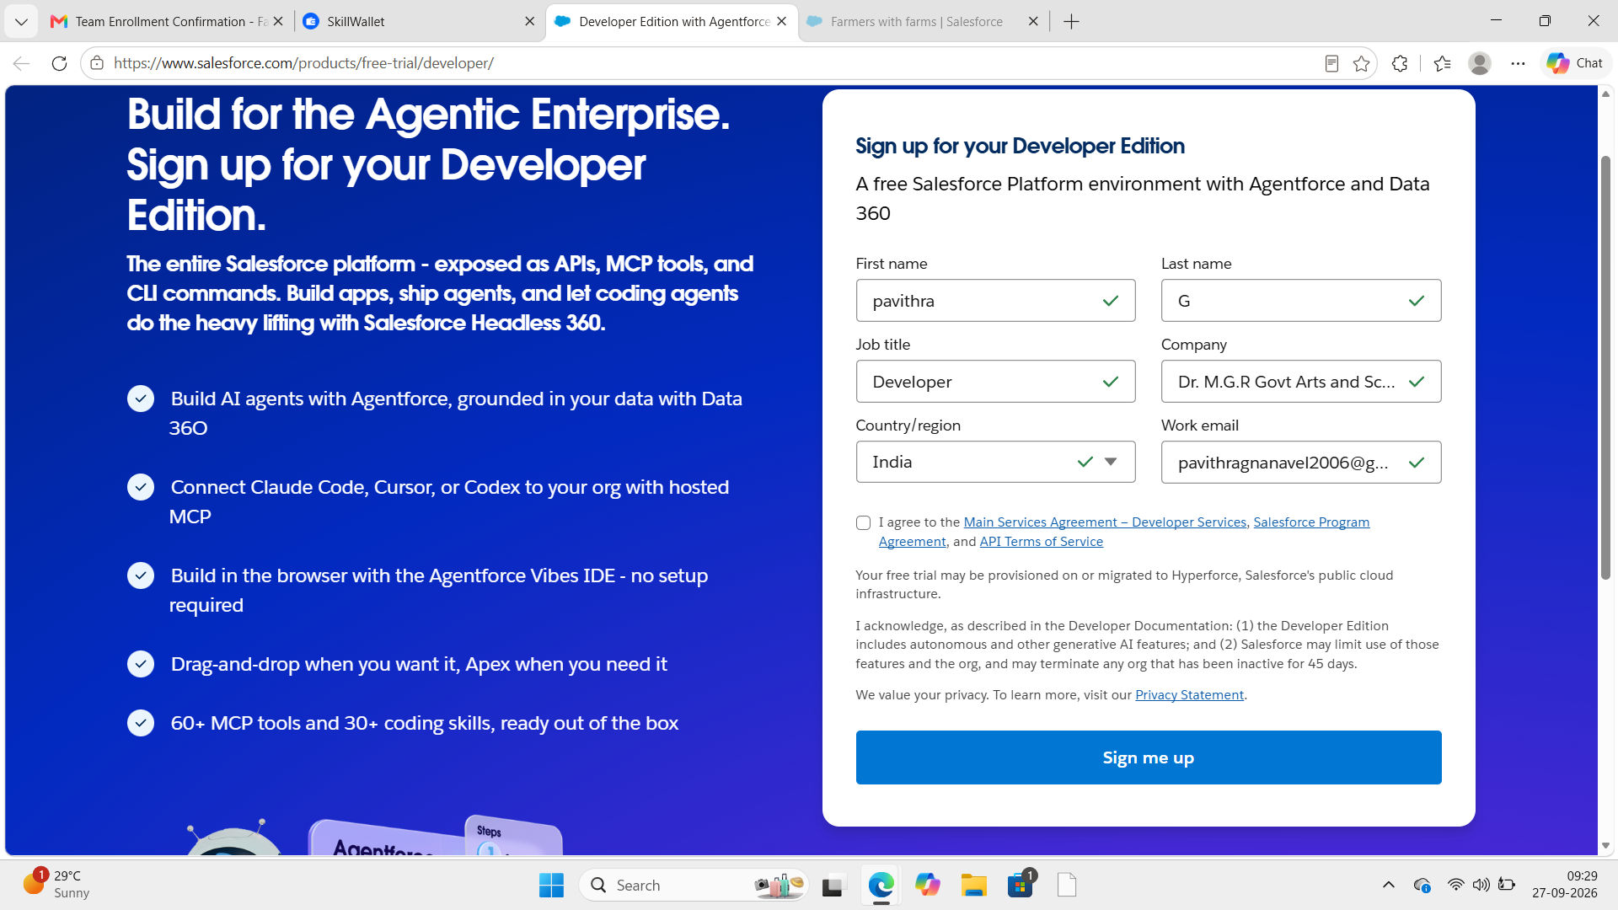
- By using username and password you can into the Salesforce org. The homepage will appear below
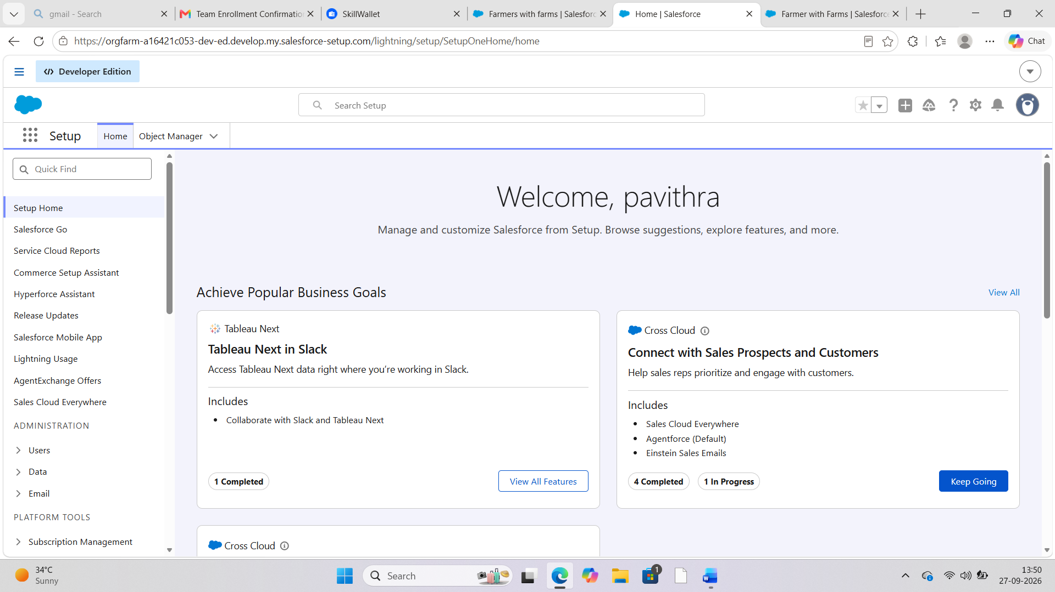

Milestone 2-Object:

What is an object?
Salesforce objects are database tables that permit you to store data that is specific to an organization. It consists of fields (columns) and records (rows).

In This Application We Use 4 Custom Objects:
1.Farm
2.Crop
3.Farmer
4.Buyer

Activity 1:
Create a custom object for Farm:
To create a custom object, follow these steps:
- From setup click on object manager.
- Click create, select custom object.

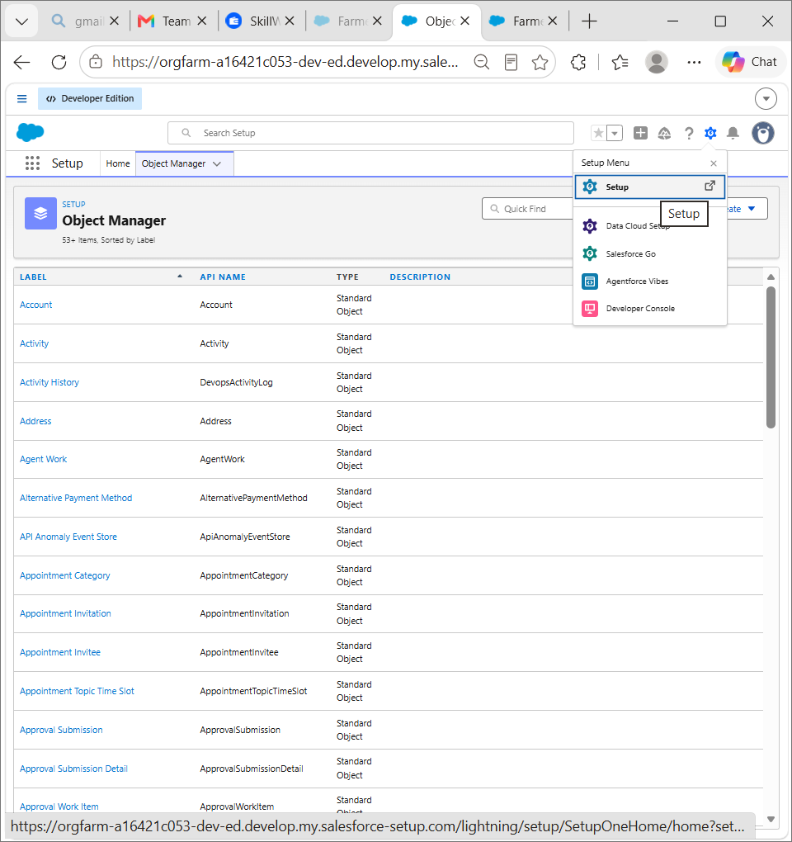

- Fill in the label as " Farm ".
- Fill in the plural label as " Farms".
- Record name: Farm Name"
- Select the data type as "Text".

- In the Optional Features section, select Allow Reports and Track Field History.
- In the Deployment Status section, ensure Deployed is selected.
- In the Search Status section, select Allow Search.
- In the Object Creation Options section, select Add Notes and Attachments related list to default page layout.

- Leave everything else as is, and click Save.
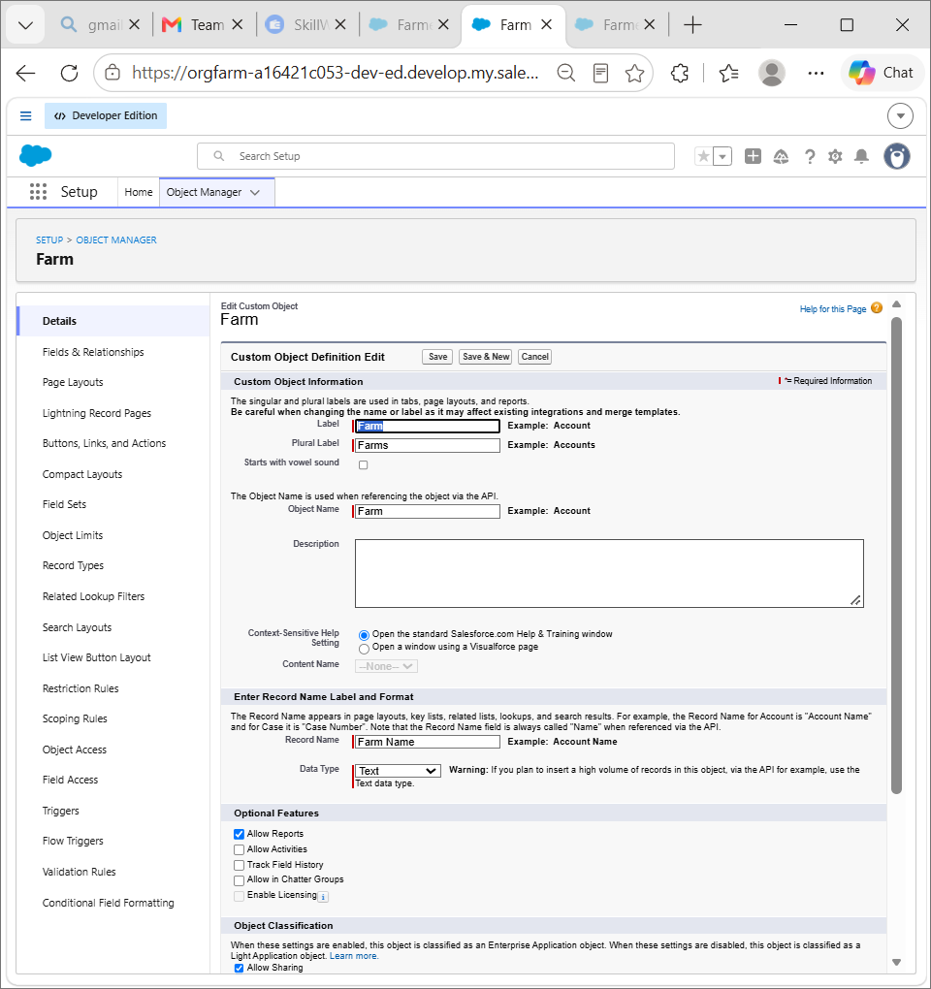
Activity 2:

Creation of Crop object:
- Click on the gear icon and then select Setup.
- Click on the object manager tab just beside the home tab.
- After the above steps, have a look on the extreme right you will find a Create Dropdown click on that and select Custom Object.
a. On the Custom Object Definition page, create the object as follows: b. Label: Crop
- Plural Label: Crops
- Record Name: Crop Name

- Select the data type as "Text".
- Check the Allow Reports checkbox g. Check the Allow Search checkbox
h. In the Object Creation Options section, select Add Notes and Attachments related list to default page layout i. Click Save.
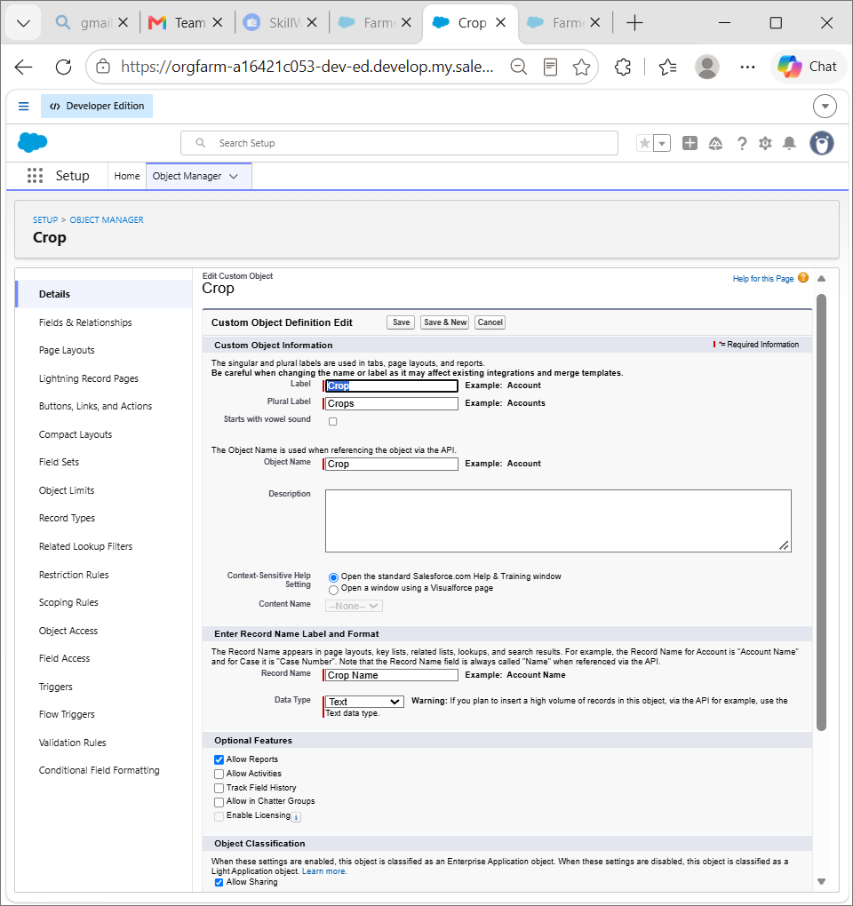
Activity 3:

Creation of Farmer object:
- Click on the gear icon and then select Setup.
- Click on the object manager tab just beside the home tab.
- After the above steps, have a look on the extreme right you will find a Create Dropdown click on that and select Custom Object.
- On the Custom Object Definition page, create the object as follows:
- Label: Farmer
- Plural Label: Farmers
- Record Name: Farmer Name e. Select the data type as "Text".
f. Check the Allow Reports checkbox. g. Check the Allow Search checkbox.
h. In the Object Creation Options section, select Add Notes and Attachments related list to default page layout. i. Click Save.
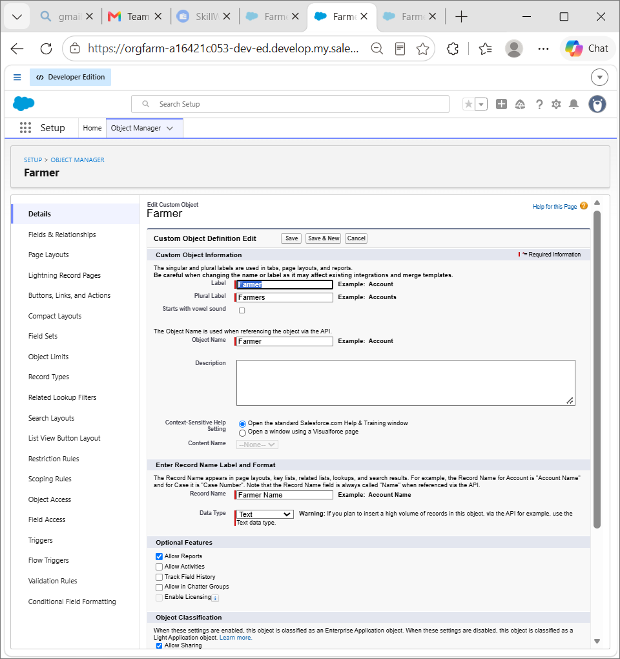
Activity 4:

Creation of Buyer object:
- Click on the gear icon and then select Setup.
- Click on the object manager tab just beside the home tab.
- After the above steps, have a look on the extreme right you will find a Create Dropdown click on that and select Custom Object.
- On the Custom Object Definition page, create the object as follows:
- Label: Buyer
- Plural Label: Buyers
- Record Name: Buyer Name
- Select the data type as "Text".
- Check the Allow Reports checkbox. g. Check the Allow Search checkbox.
h. In the Object Creation Options section, select Add Notes and Attachments related list to default page layout. i. Click Save.
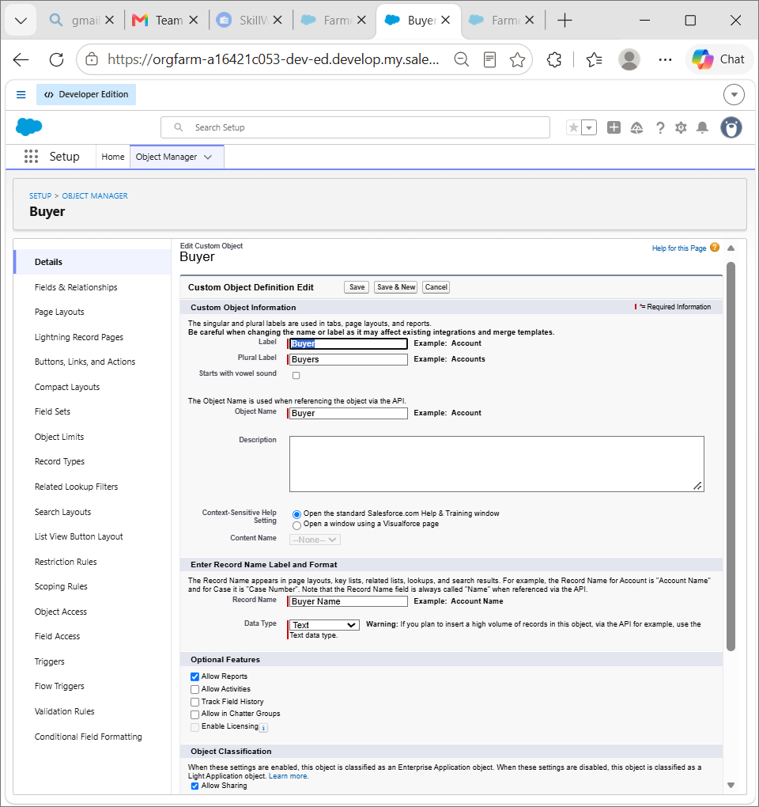
Milestone 3 -
Tab: Tab

Tabs in Salesforce help users view the information at a glance. It displays the data of objects and other web content in the application.

Activity 1:

Creation of Farm tab:

Now create a custom tab.

- Click on the Home tab, enter Tabs in Quick Find and select Tabs.
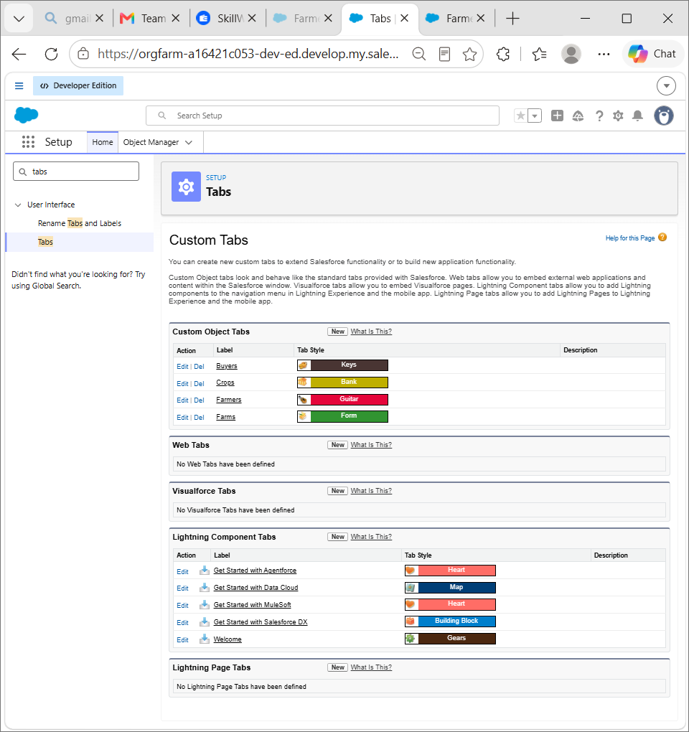

- Under custom object tabs, click New.
- For Object, select Farm.
- For Tab Style, select any icon.
- Leave all defaults as is. Click Next, Next, and Save.

Activity 2:

Creation of Crop tab:
Now create a custom tab.
- Click on Home tab, enter Tabs in Quick Find and select Tabs.
- Under custom object tabs, click New.
- For Object, select Crop.

- For Tab Style, select any icon.
- Leave all defaults as is. Click Next, Next, and Save.

Activity 3:

Creation of Farmer tab:

Now create a custom tab.
- Click on the Home tab, enter Tabs in Quick Find and select Tabs.
- Under custom object tabs, click New.
- For Object, select Farmer.
- For Tab Style, select any icon.
- Leave all defaults as is. Click Next, Next, and Save.

Activity 4:

Creation of Buyer tab:

Now create a custom tab.
- Click on Home tab, enter Tabs in Quick Find and select Tabs.
- Under custom object tabs, click New.
- For Object, select Buyer
- For Tab Style, select any icon.
- Leave all defaults as is. Click Next, Next, and Save.

Milestone 4 - Lightning App:
What is an App?
Apps in Salesforce area group of tabs that help the application function by working together asa unit. It has a name,a logo, and a particular set of tabs. The simplest app usually has just two tabs.

Activity 1:
Create the Farm Management System app
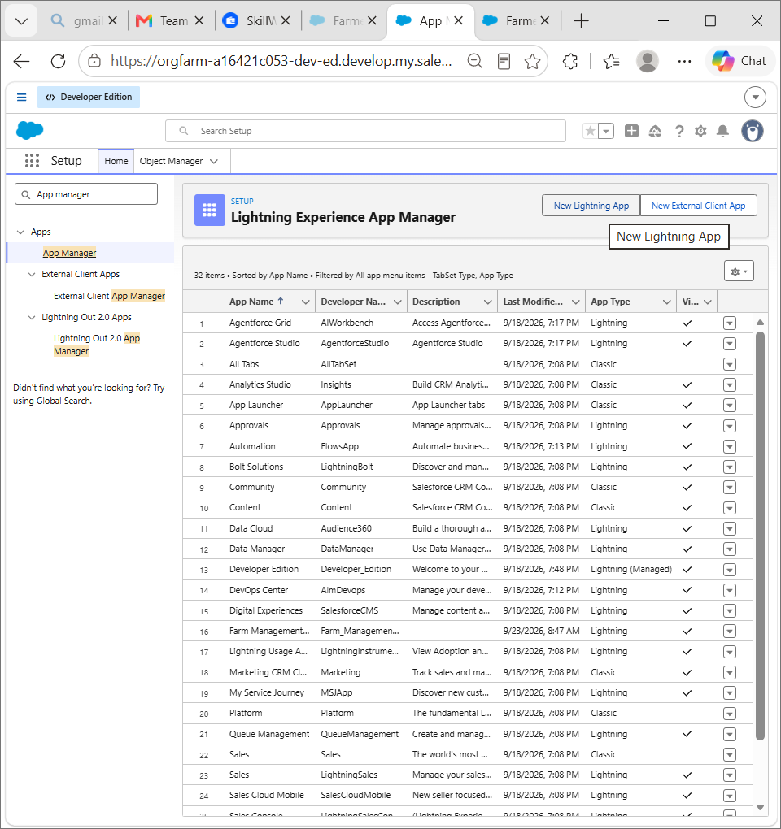

- From Setup, enter App Manager in the Quick Find and select App Manager.

- Click New Lightning App. Farm Management System as the App Name, then click Next
- Under App Options, leave the default selections and click Next.
- Under Utility Items, leave as is and click Next.
- From Available Items, select Farm, Crop,Farmer,Buyer
Reports,and Dashboards and move them to Selected Items. Click Next. ● From Available Profiles, select System Administrator and move it to Selected Profiles.Click Save & Finish.
- To verify your changes, click the App Launcher, type Farm Management System and select the Job Application app.
Note:
- App Launcher-Displays available apps.
- App Name-Displays the current selected app.
- Navigation menu-Displays the tabs available inside the app.

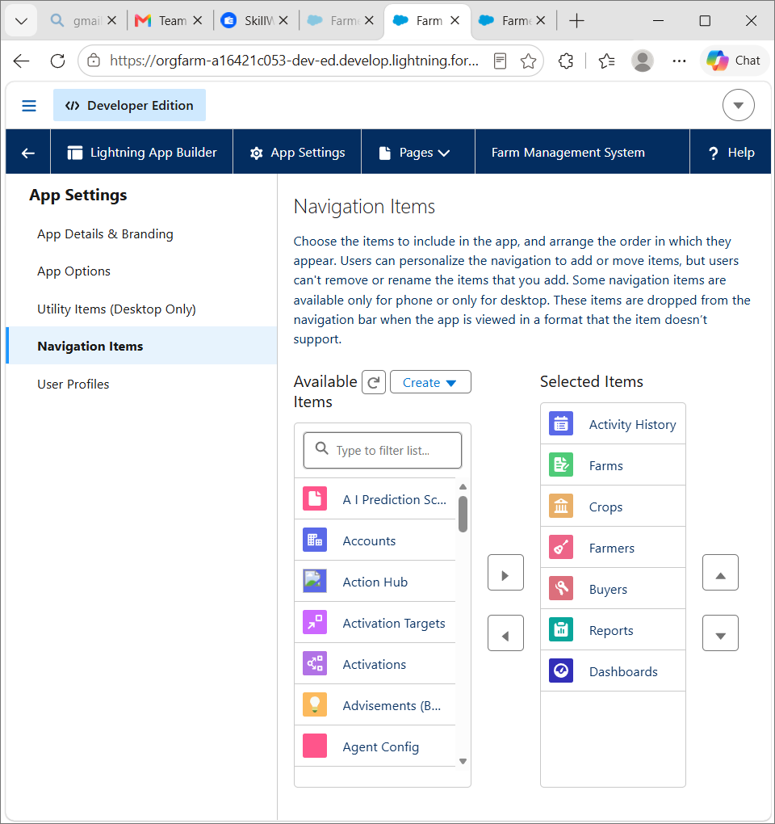

Milestone 5 -
Fields and Relationship: What are fields?

Fields in Salesforce represent what the columns represent in relational databases. It can store data values which are required for a particular object in a record.

Activity 1:
Creation of fields for the Farm objects:
- click the gear icon and select Setup. This launches Setup in a new tab.
- Click the Object Manager tab next to Home.
- Select Farm.
- Select Fields & Relationships from the left navigation, and click New
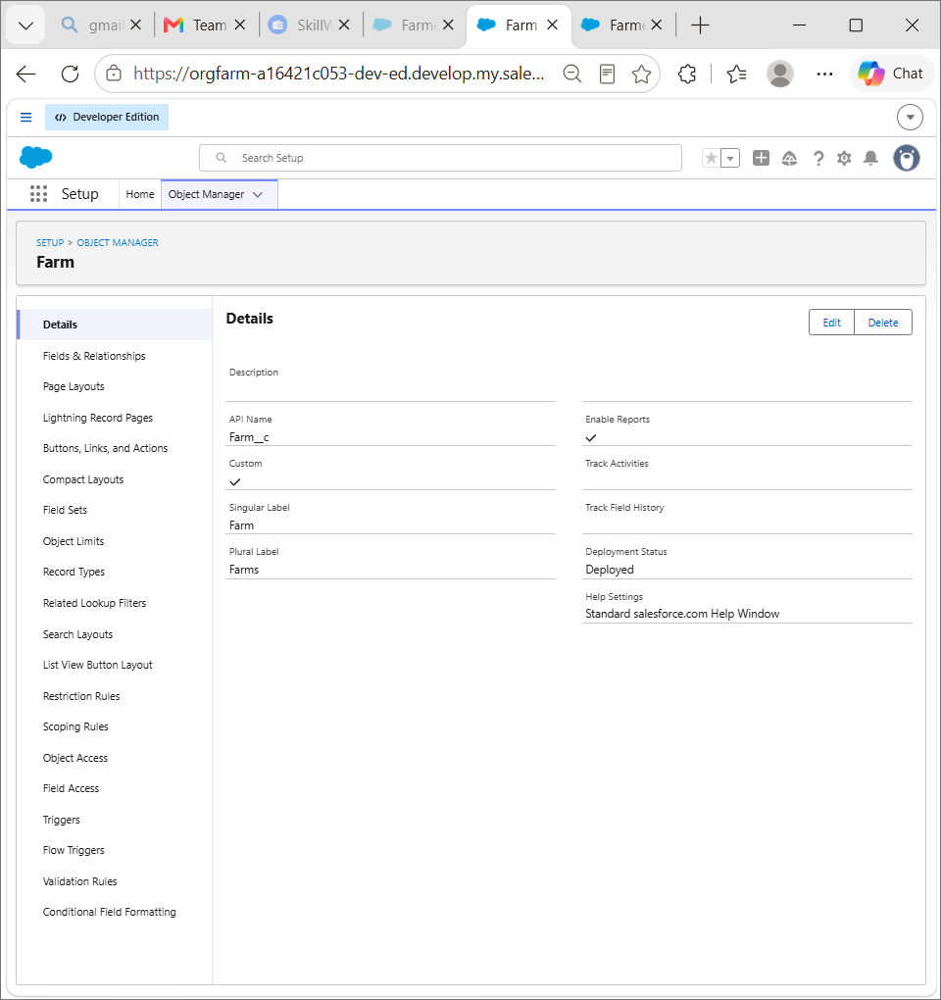
5.Choose Data type as a picklist,Click next
6.Enter Field Label (Farm Type),and Enter Values as (Crop,Livestock,Mixed)
7.Next,Next Click Save.

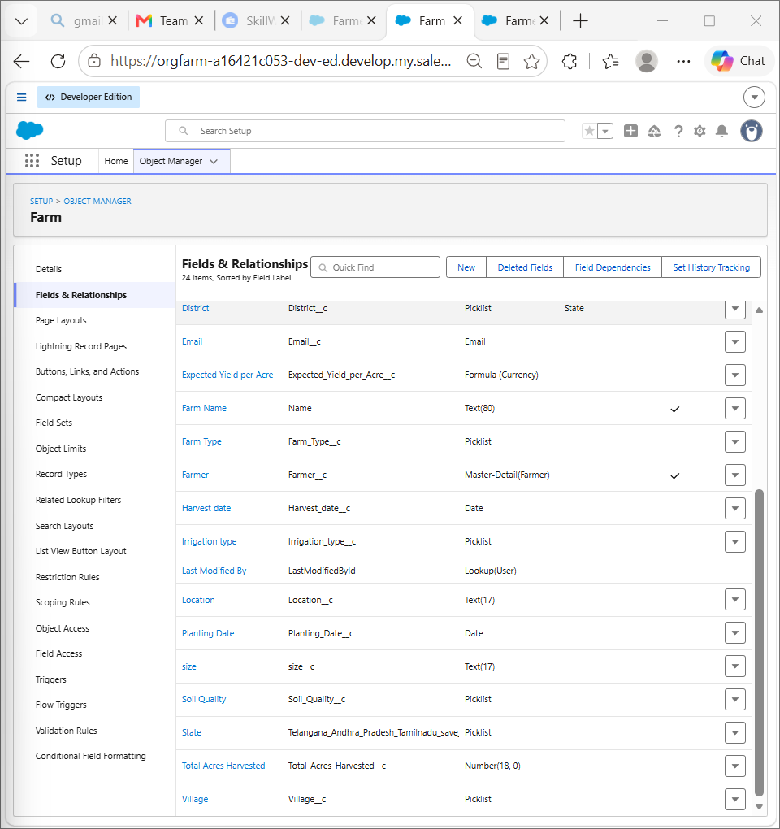

Now let's create the other fields following Activity1 steps 1 to 4 and we must choose the data types of the fields carefully.

1.Next we Create another Picklist Field,Enter field label (Soil Quality) enter values
(Organic,Cover Crops,Composting)
2.Again we Create Picklist field,Field Label (Irrigation type), Enter Values (Sprinkler irrigation,Drip irrigation,localized irrigation)
3.Choose data type as a text,enter field label(Location) 4.Choose data type as text,enter field label (size)
5.Create a Master Detail relationShip with Farmer Object.
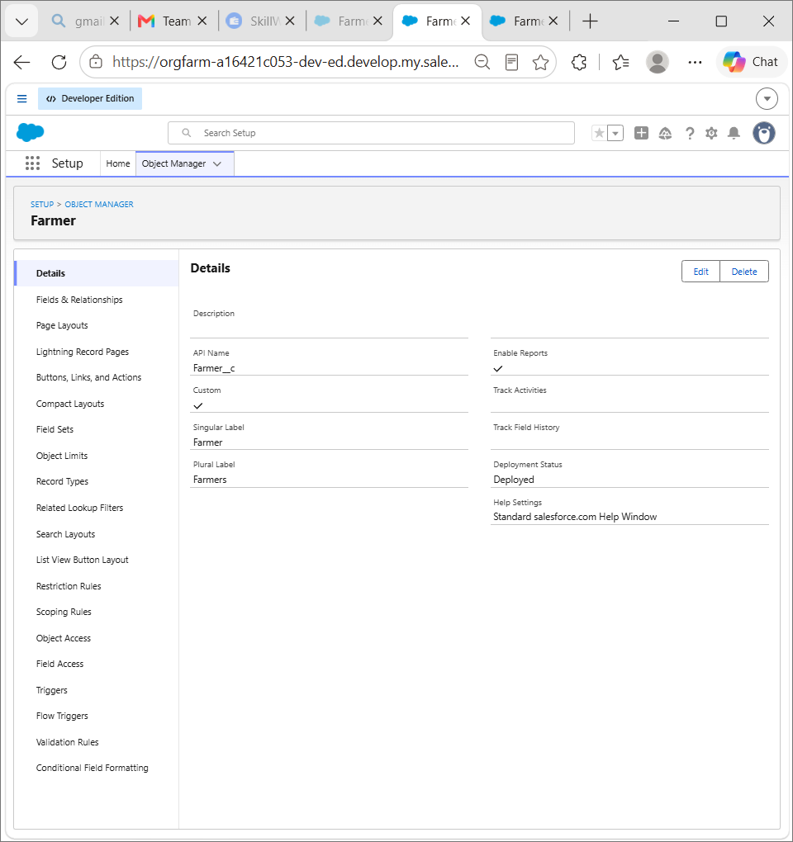
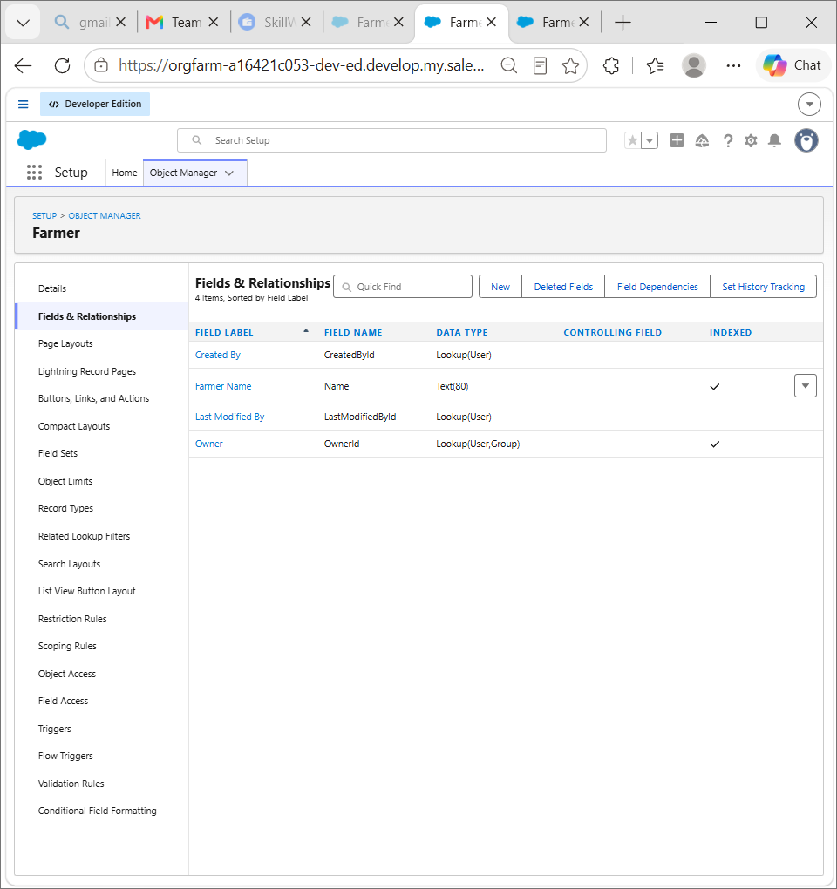
Activity 2:
Creation of fields for the Crop objects:

1.Choose Data type As a text,Enter Field Label name (Crop Name),Next save. 2.Select Data type as date ,Enter Field label (Planting Date),then save .
3.Again we select data type as a date,Enter field labe (Harvest date),save
4.Next We Create Lookup relationship on crop object realted to Farm Object.
5.We select adata type as currency,Enter field Label (Actual Yield), Next Save it. 6.Select Data type as a Number,enter Field Label (Total Acres Harvested),Enter Maximum Length(20) and save.
7.Now We create Formula Field For That Select data Type As a Formula,Click Next.
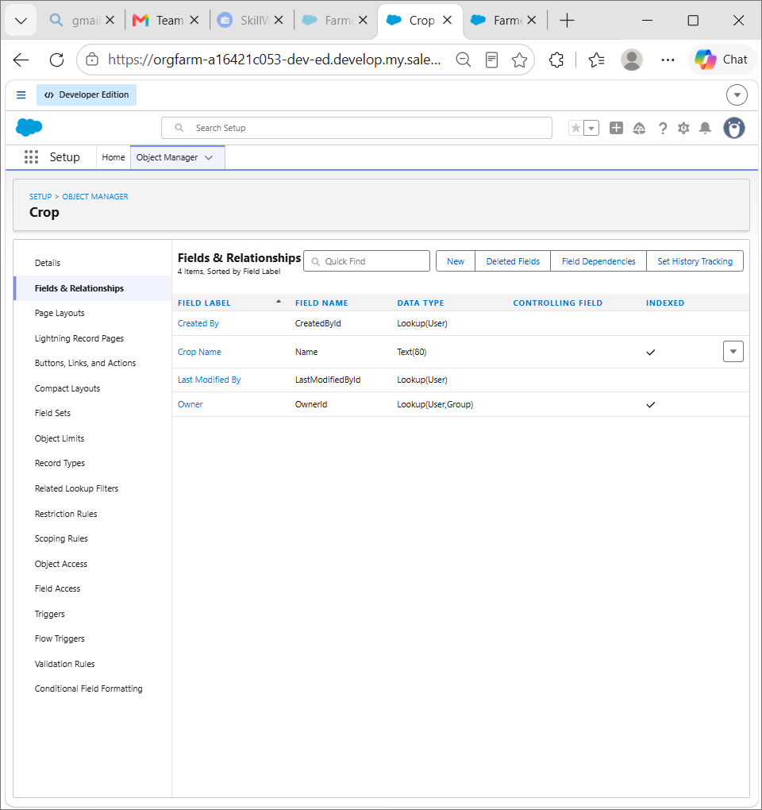

8.Enter Field Label (Expected Yield per Acre),Select formula return type as Currency,click Next.
9.Enter a Formula Actual Yield Divide By Total Acre Harvested, then click next and save.

Activity 3:
Creation of fields for the Farmer objects:

1.Select Data type Phone,Enter field label(Contact Number),next Save.
2.Select Data type Picklist,Enter Field Label(State),Enter values (Telangana,Andhra Pradesh,Tamilnadu),save.
3.Choose Data type Picklist,Enter Field Label (District),Enter Values of district,next save. 4.Again select Data type as Picklist,Enter Field Label (Village),Enter Values of villages,next save.

Creation of field dependency :

1.Now create Field Dependency For District field,Open Object Manager,Choose Farmer object ,select Fields&Relationships,On Right side We have Field Dependency option,select that option.
2.Click new, Select Controlling Field as State,Dependent Field As District,Click on Continue.
- Select the appropriate Value in each column by double-clicking them.
- For Ex. Telangana - Yadadri Bhongir.
5.Click Include Values. And it is also the same for Andhra Pradesh, Tamilnadu with its city.

6.Click Preview, then test the dependency by selecting a different State and viewing the associate Values available for Particular state.

7. Click Close to close the preview window, Click Save.

Activity 4:

Creation of fields for the Buyer objects:

1.Select Data type as a Phone,Enter a Field Label(Contact),Save.
2.Select Data type as an Email,Enter Field Label(Email), Next save.
3.Select Data type Text area,Enter Field Label(Address),Save it.
4.Select Data type Picklist, Field Label(Buyer Type),Enter values (Wholesale,Retail),Click Save.
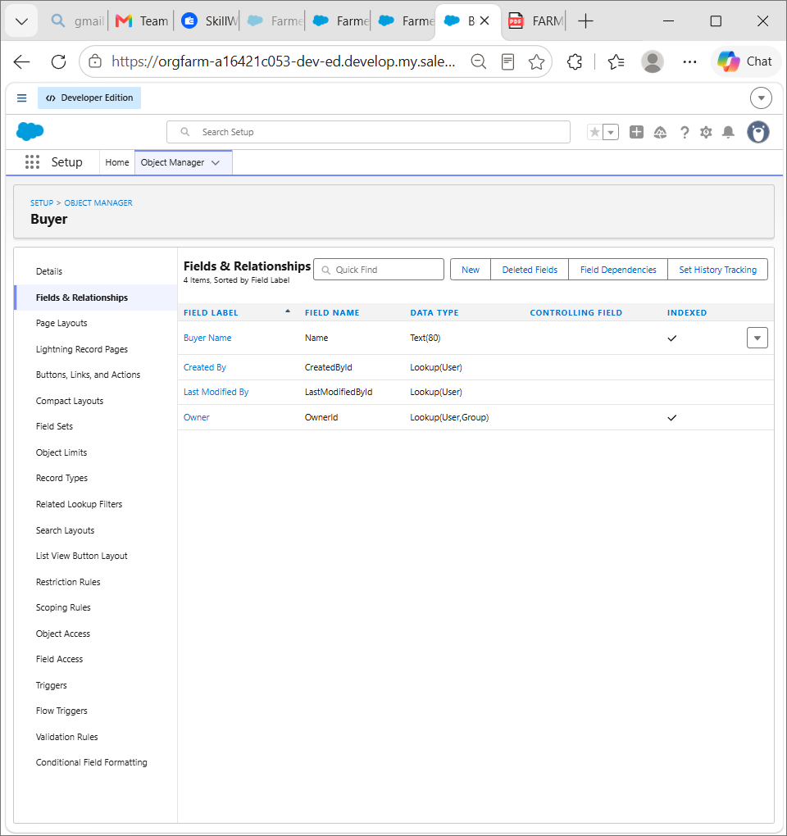

Milestone 6- Profile:

What is a profile?
A profile is a group/collection of settings and permissions that define what a user can do in
salesforce. A profile controls “Object permissions, Field permissions, User permissions, Tab
settings, App settings, Apex class access, Visualforce page access, Page layouts, Record Types, Login hours & Login IP ranges.
A profile can be assigned to many users, but user can be assigned single profile at a time.

Activity 1:

Create a custom profile:
- From setup , enter profiles in Quick Find box
- Select profiles (Standard user).
- Click clone.
- For Profile, enter Sales Department.

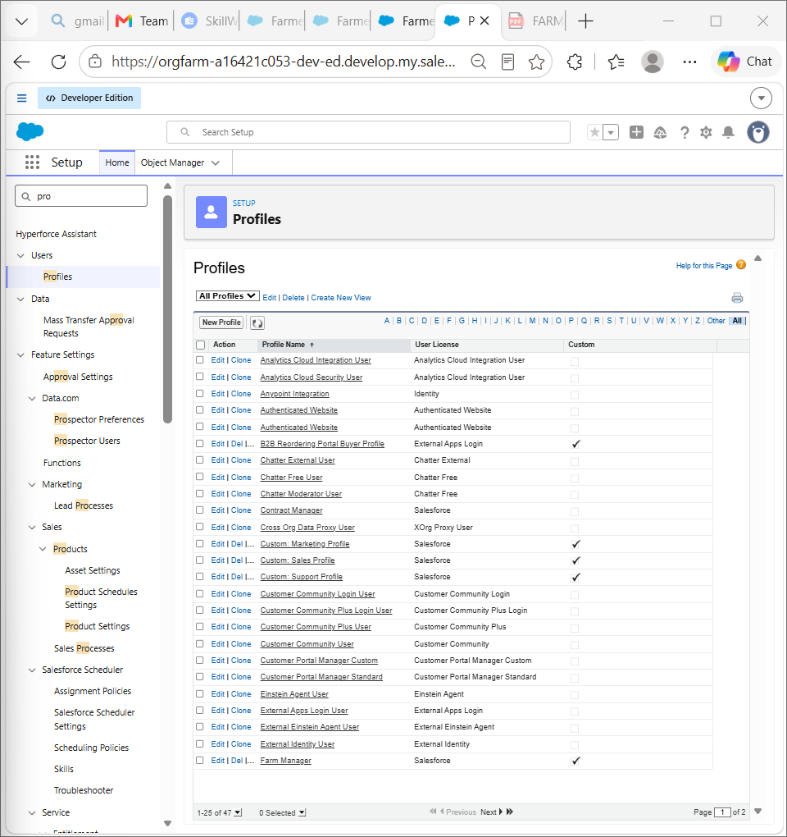

- Click save.

Activity 2:

Create a custom profile-2:
Create a profile with the profile name as “ Farm Manager” .

- From setup , enter profiles in Quick Find box
- Select profiles (Standard user).
- Click clone.
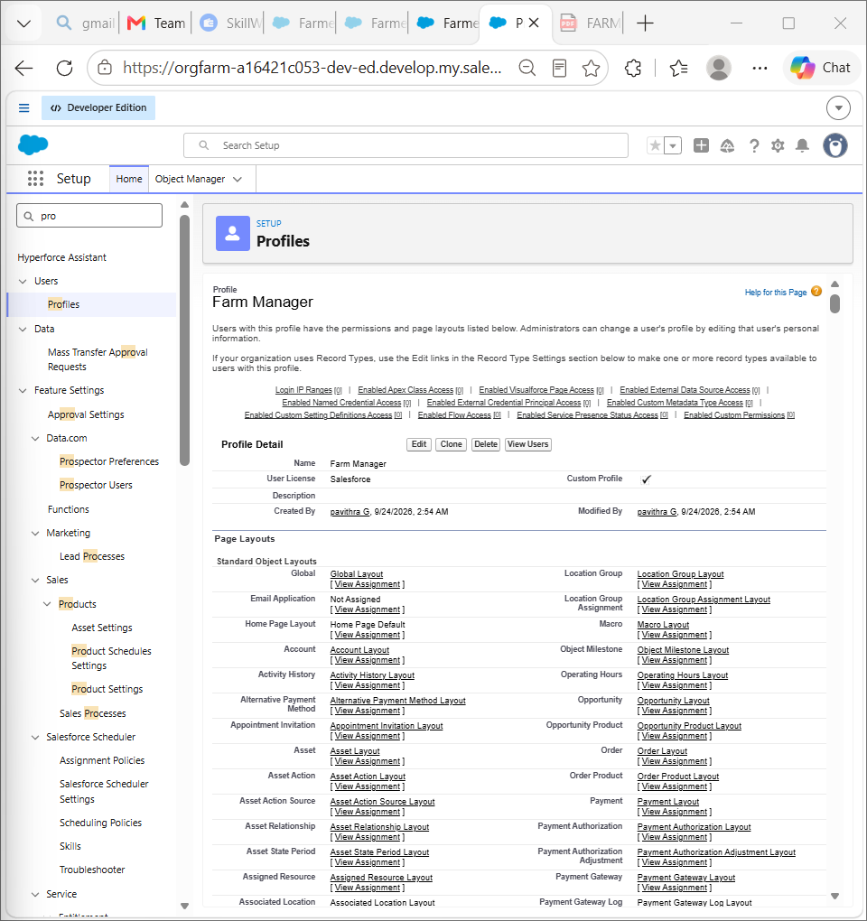

Milestone 7- Role

In Salesforce, roles are used to determine which users have access to certain data and functions within the system. They are also used to define the reporting hierarchy within an organization. Users with higher roles have greater access to data and more control over the system.

Activity-1
Creation of role

1. From the Quick find box search for the role and click on the roles option 2. select the set up roles option
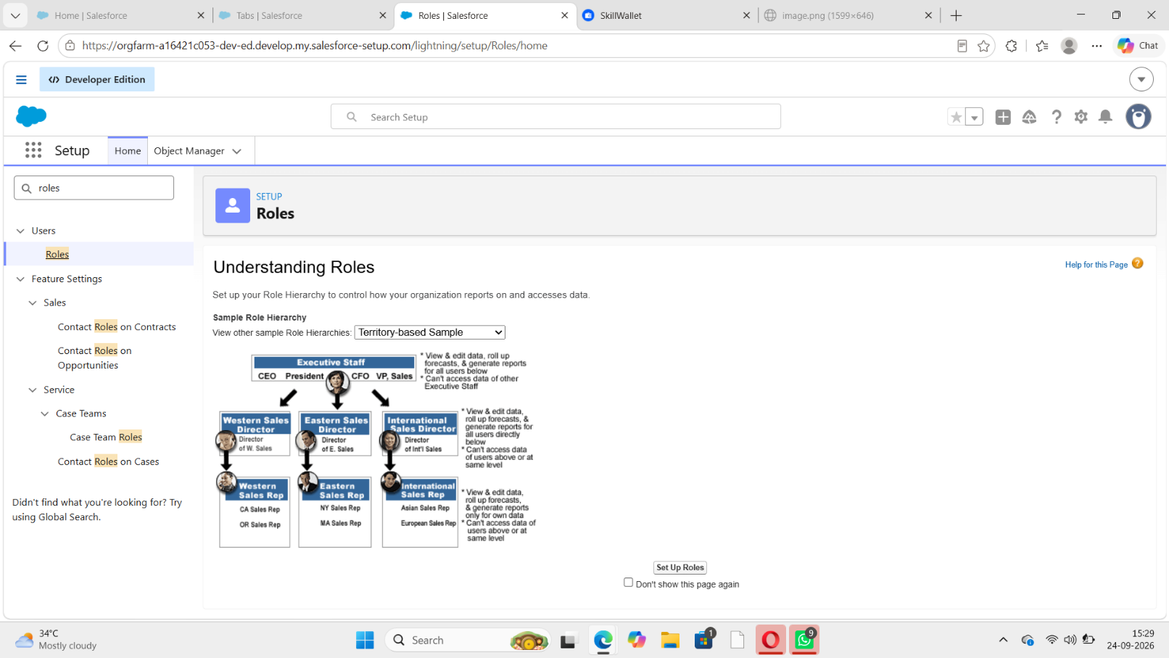

3.Below the CEO click on add role and enter the label name as a ” Farm Manager ” and role name will be Automatically populated and click on save.

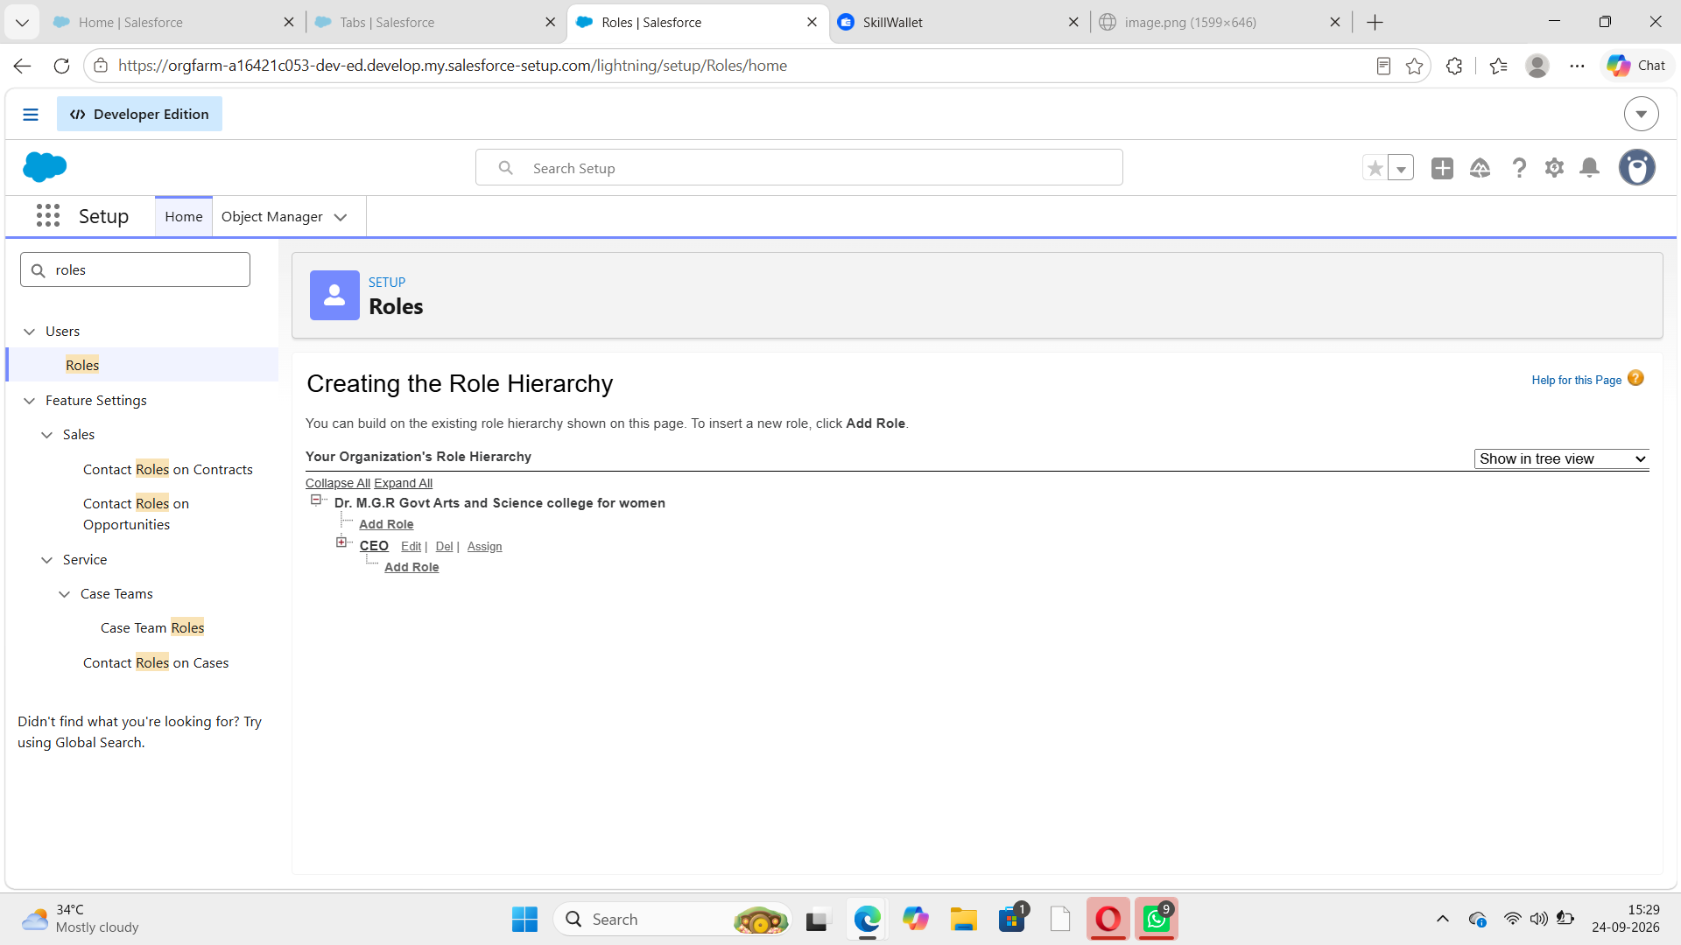

Milestone 8-User :

What is a user?
A user is anyone who logs into Salesforce. Users are employees at your company, such as sales reps, managers, and IT specialists, who need access to the company's records. Every user in
Salesforce has a user account. The user account identifies the user, and the user account settings determine what features and records the user can access.

NOTE- As Salesforce license can only be used by 2 Users at a time in Dev Org, so If you don’t find salesforce license then deactivate a user who has salesforce license Or change the license type from Salesforce to any other.

Activity 1:

To Create a user:
- From Setup, enter Users in the Quick Find box, then select Users.
- Click New User.

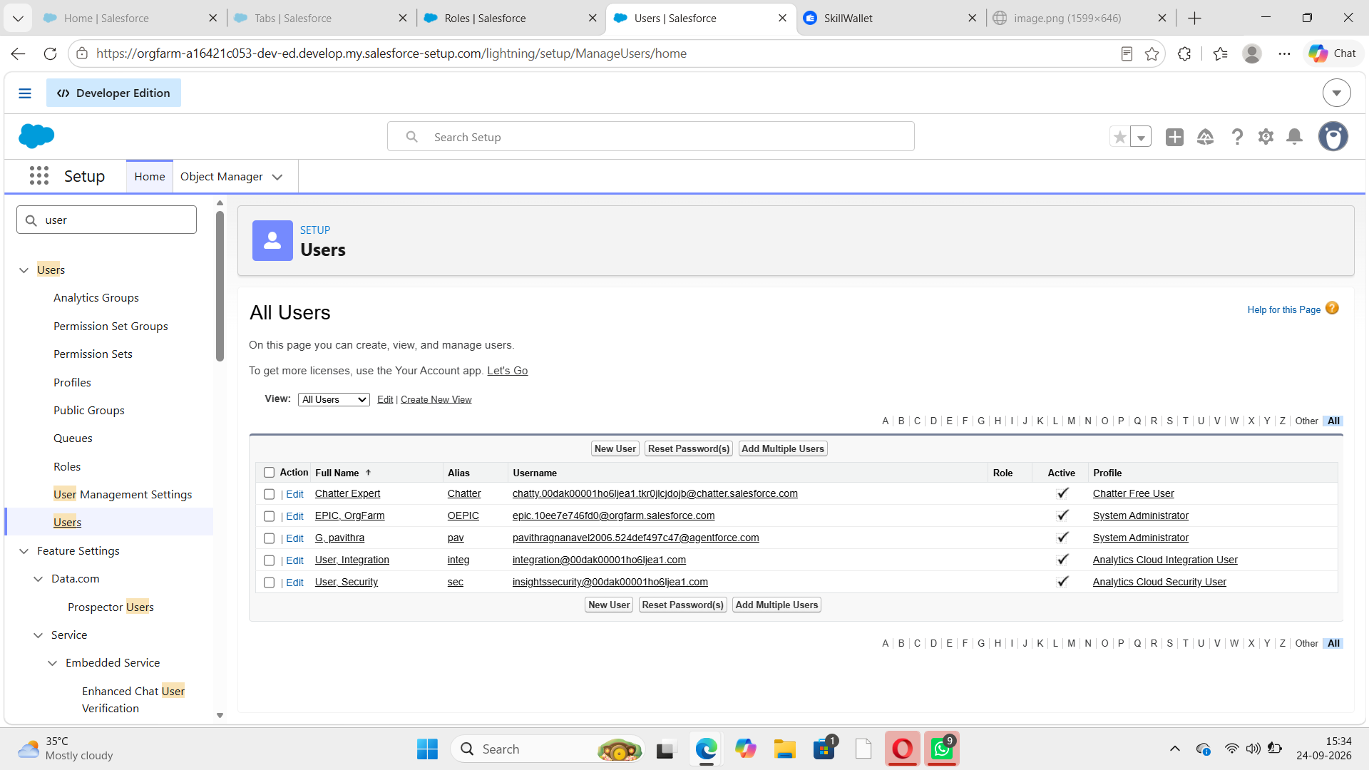

- Enter First name as Farm and last name as Manager.
- Enter the user’s name and email address and a unique username in the form of an email address. By default, the username is the same as the email address.
- Select the role Farm Manager.
- Select user License as Standard Platform User.
- Select profile(Farm Manager).
- Click save.
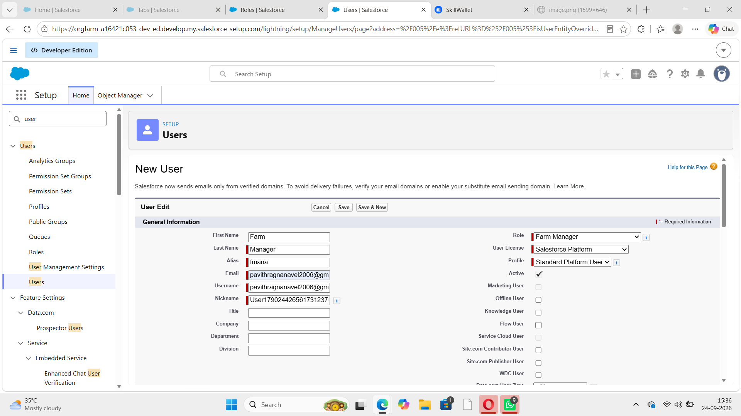

Activity 2:
Create a user with a username as “Sales Department”, and assign him the sales Manager profile. Follow the steps from above Activity
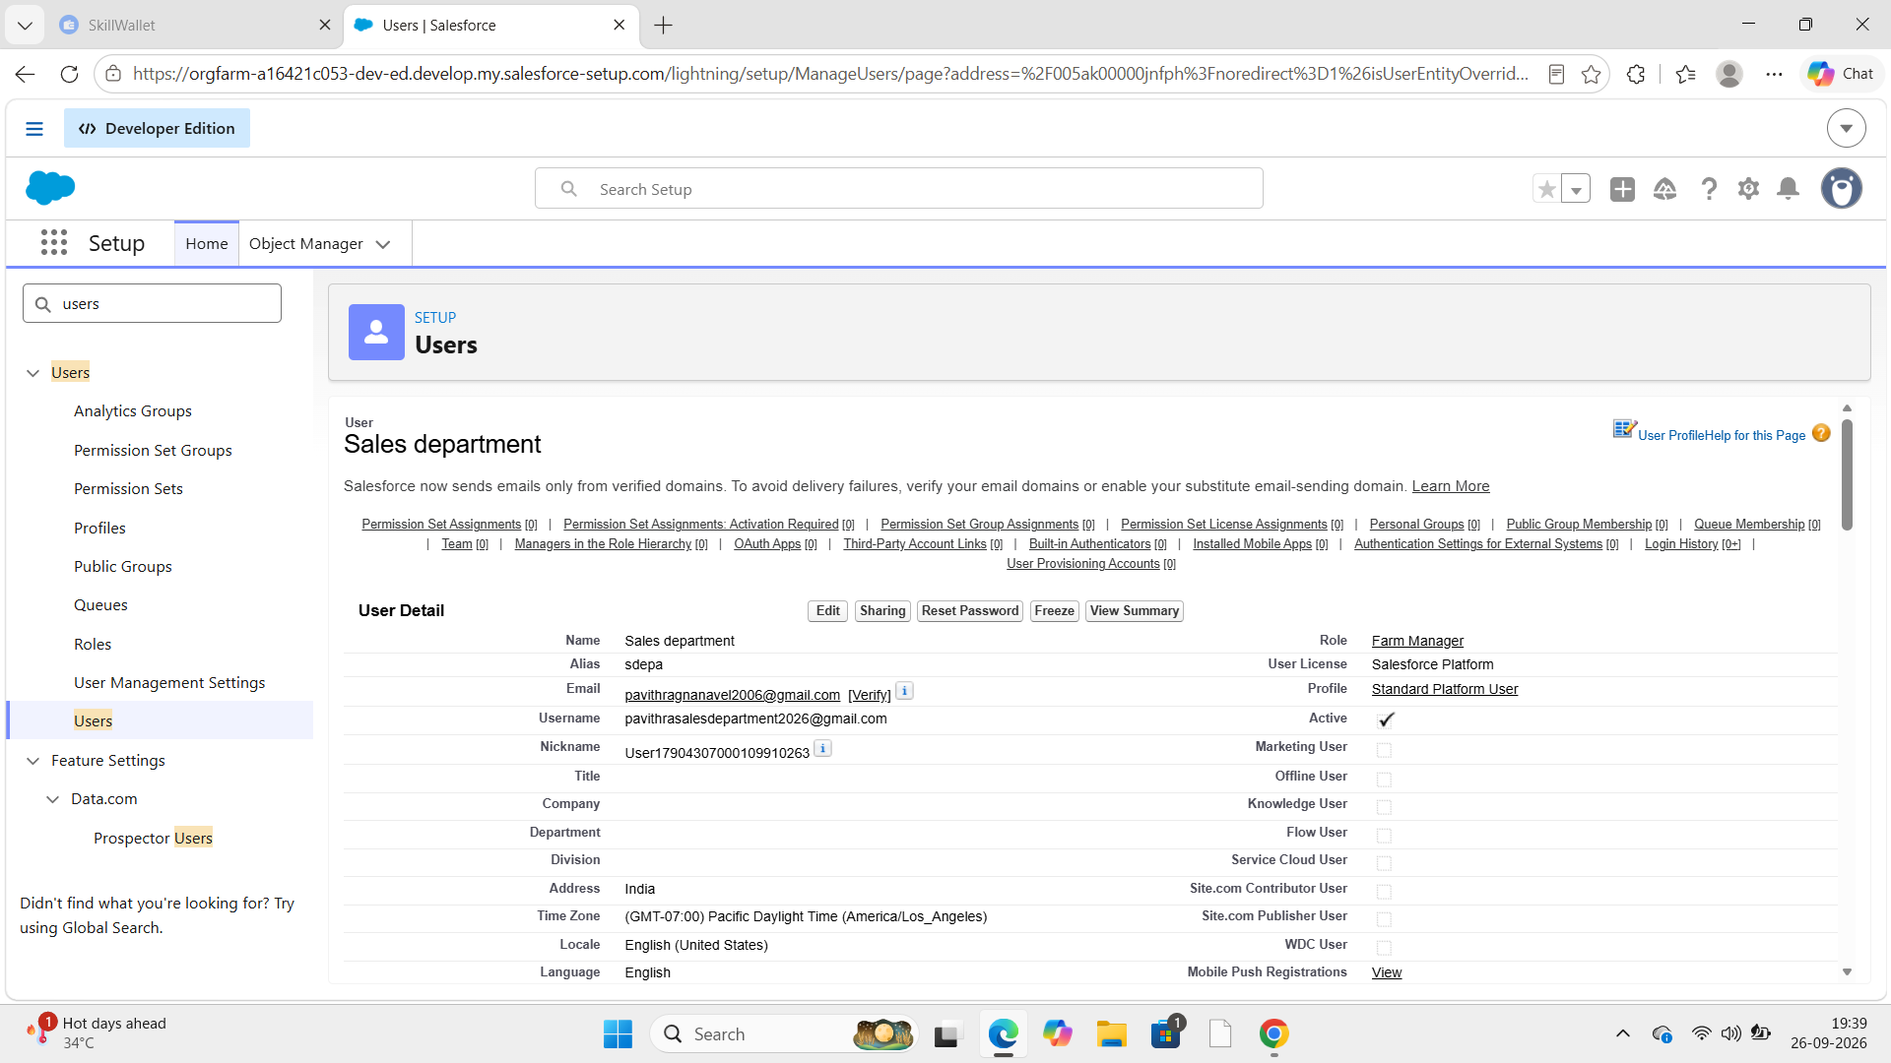

Milestone 9-Sharing Rules:

What are Sharing Rules?
Sharing rules help users to share records based on conditions. It is basically created for objects whose organization-wide defaults (OWD) are set to public read-only or private because sharing rules can only extend the access and not restrict it.
Types of sharing rules,
•Owner-based Sharing Rules •Criteria-based Sharing Rules

Activity 1:

Create a sharing rule
- Goto Sharing Settings, which can be found under the Quick Find section.
- Scroll down and find the candidate object where a sharing rule needs to be added, and then click on New to create a new sharing rule.
- Add the label of the sharing rule you want to make.
- Select your rule type based on the criteria.
- Select the field can join immediately check field from the Crop object.
- Select the Crop as equal and value is True.
- And in selecting the users to share with the section select roles and in that select Farm Manager.
- And in the section of select the level of access for the users give the access Read/Write.
- And save the rule.
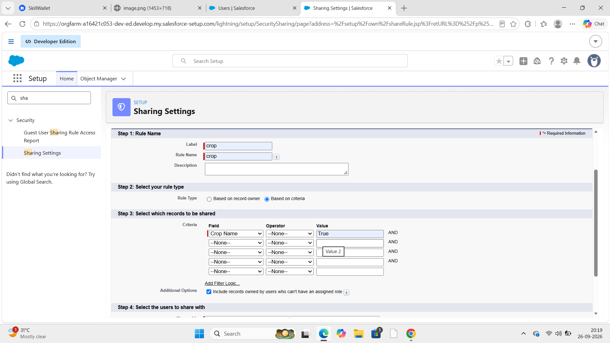

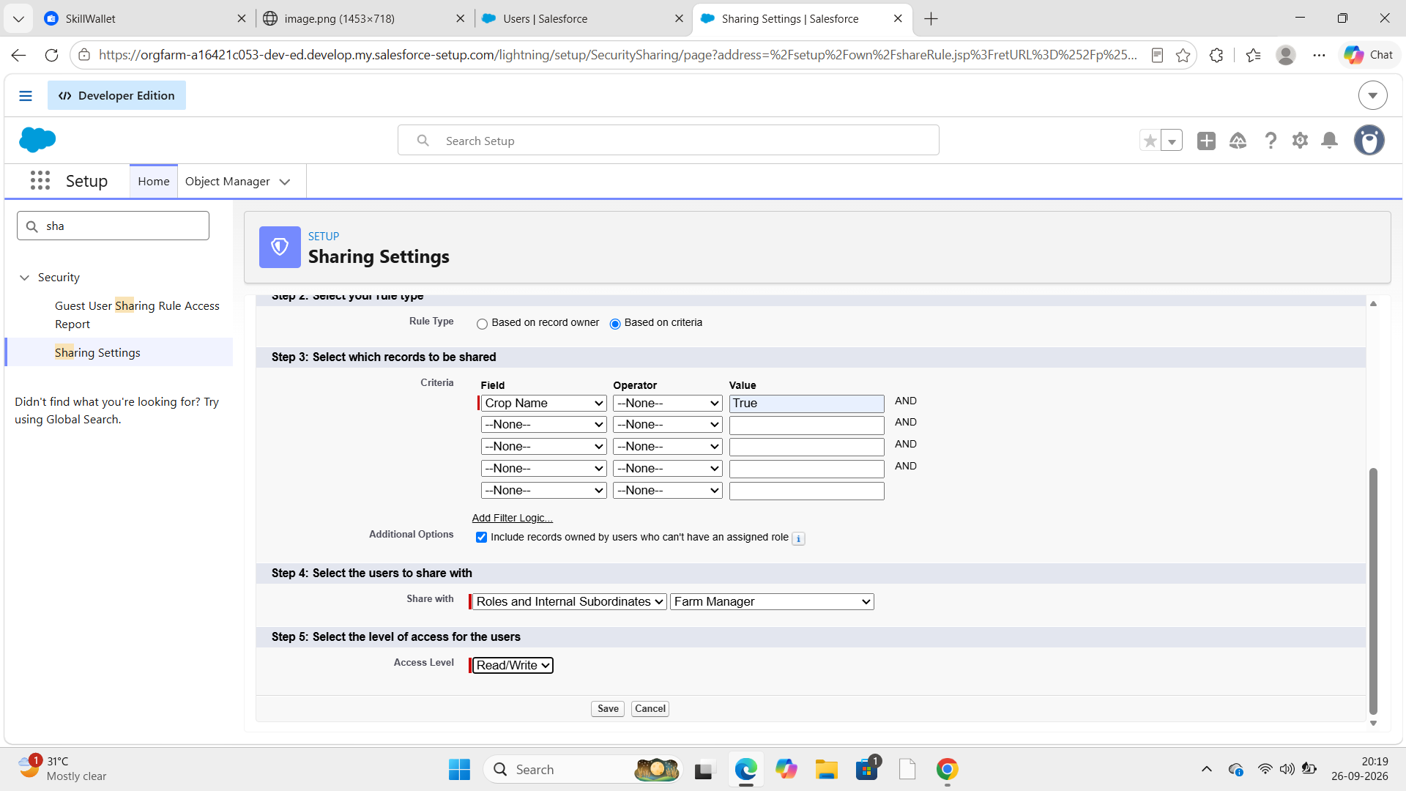

Activity 2:

Create a Sharing Rule to Share the records of Buyer to Sales department with the Access of Read/Write.
Follow the steps from above Activity.
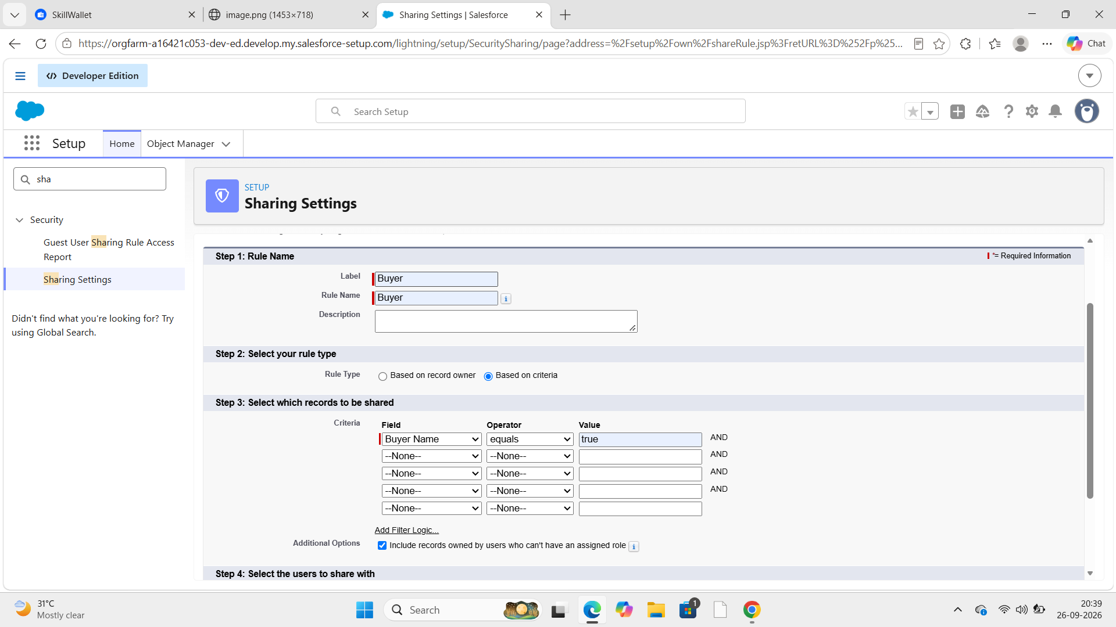

Milestone-10: User Adoption

Activity 1:Create a Record(Farmer) ● Click on App Launcher on left side of screen.
- Search Farm Management & click on it.
- Click on Farmer Tab.
- Click new and fill details & Save.

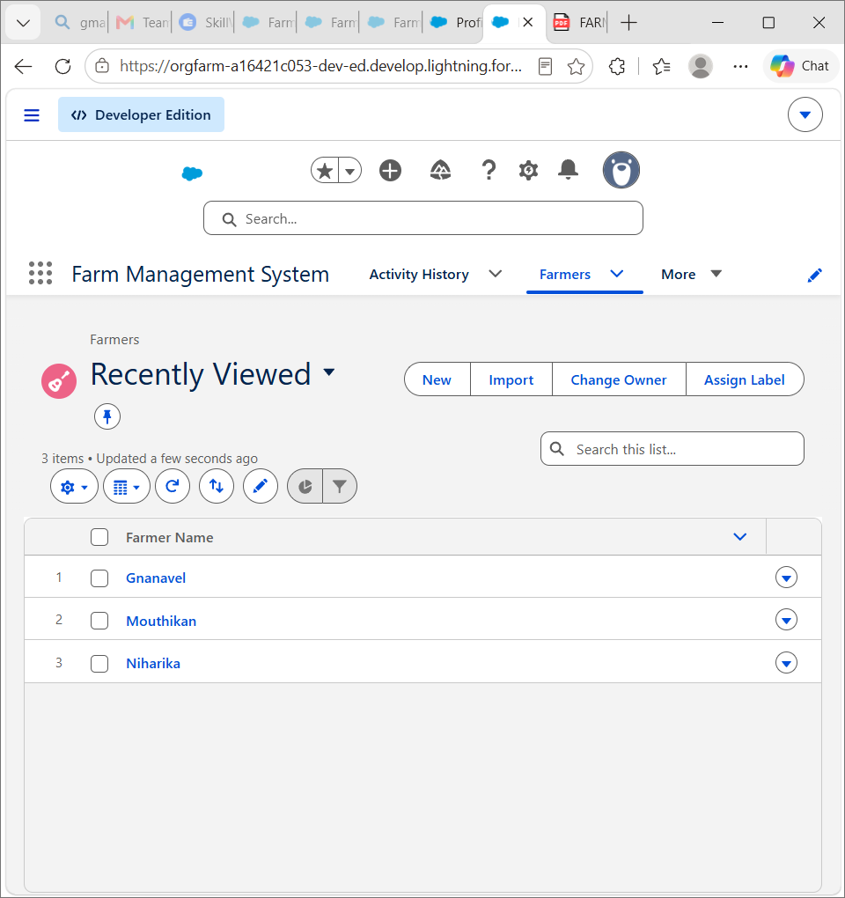
Milestone 11-Reports:

What are Reports?
A report is a list of records that meet the criteria you define. It's displayed in rows and columns, and can be filtered, grouped, or displayed in a graphical chart. Every report is stored in a folder. Folders can be public, hidden, or shared, and can be set to read-only or read/write.

Activity 1:
Create a report:
Create a report that displays rating of the account and which has type and account name.
- Click on app launcher search for reports.
- Click on the new report and select the category has Farmer with Farms.
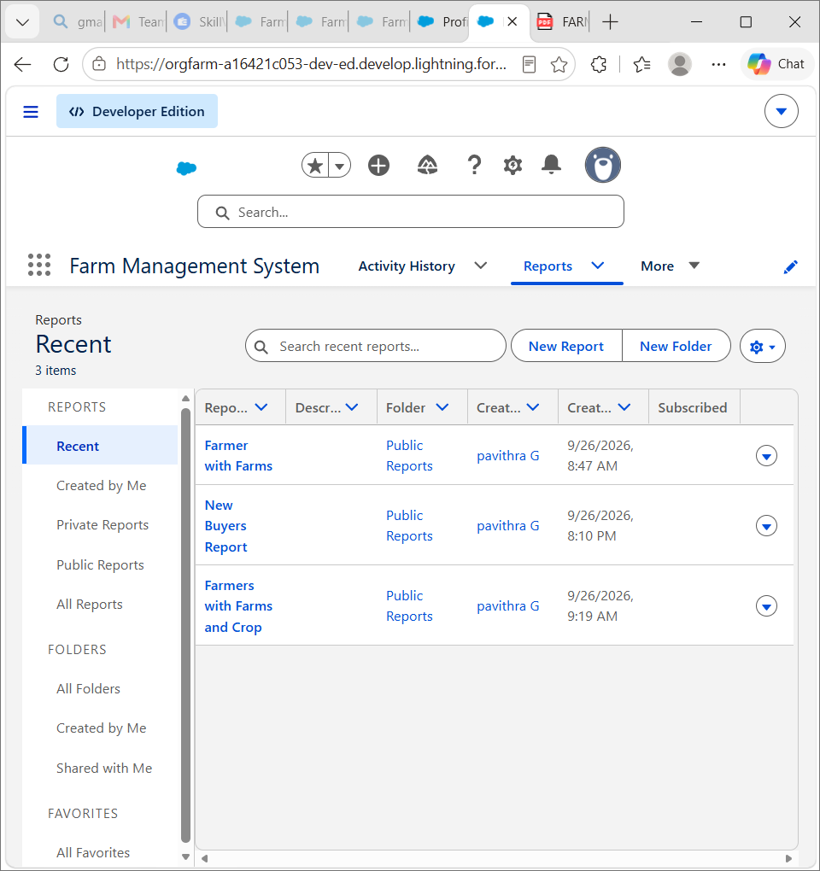
- In the details section select the option start report.
- In Outline Click on Column Select Which Field you want to display in the Report.
- Click Group,Select Which Fields You Want to Group.
- Save the report by giving label name(Farmer with Farms) and save the folder as a public folder and save the report.

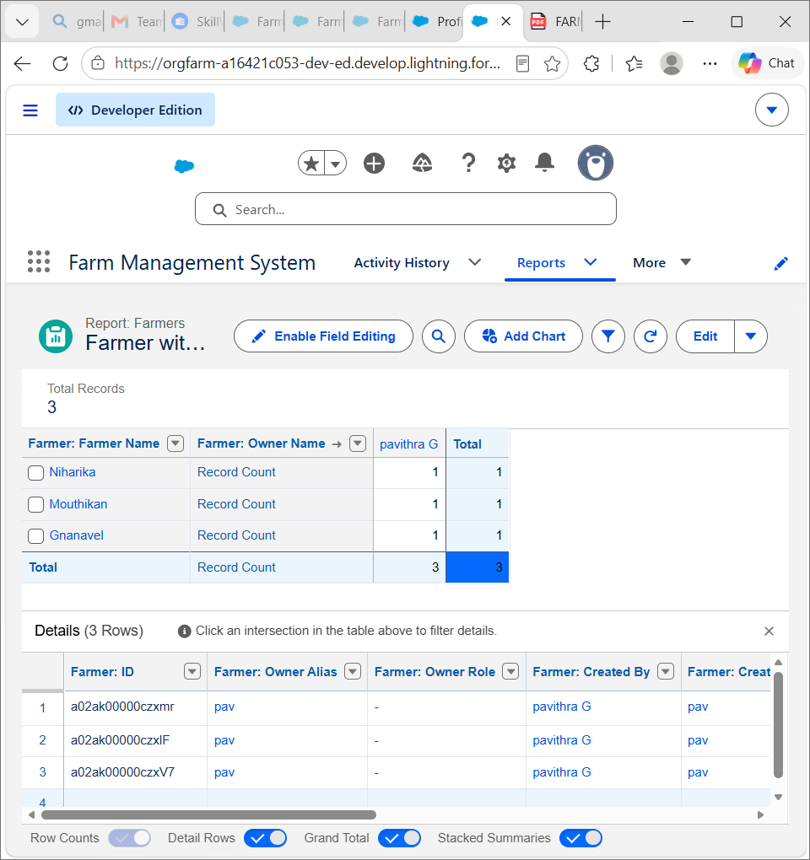
Activity 2:
Create a Report using the Objects Crops, Buyers. Follow the steps from above Activity.

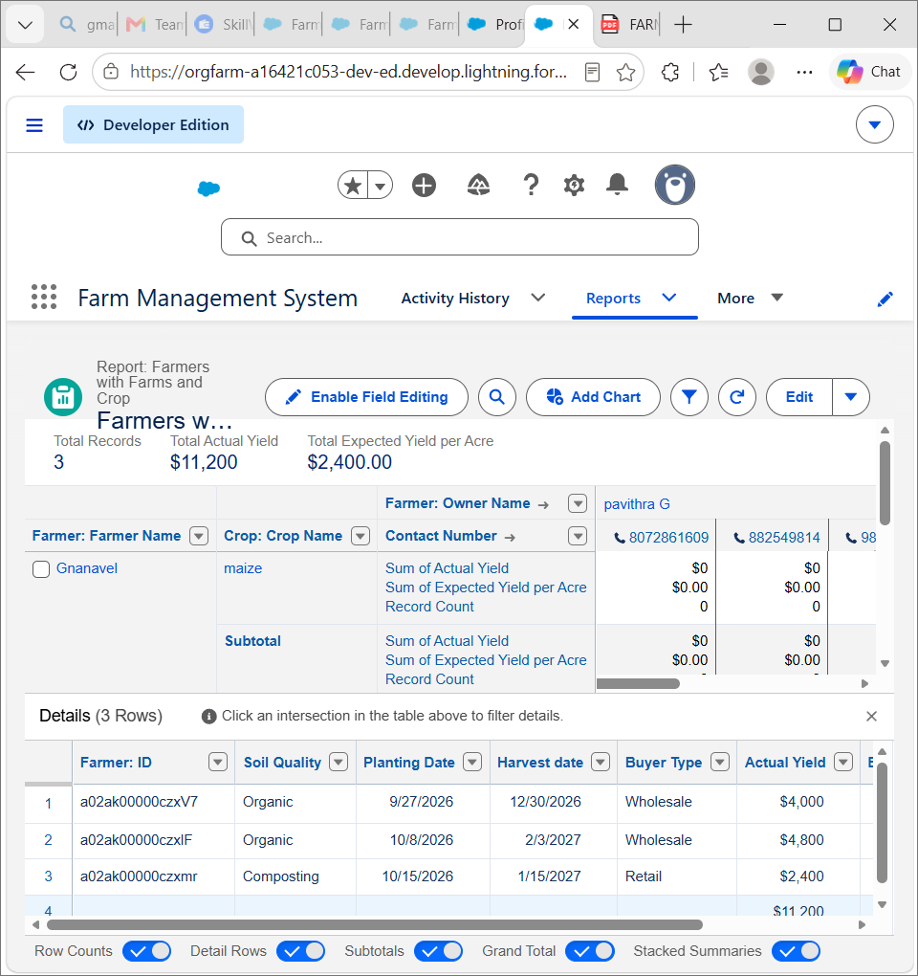
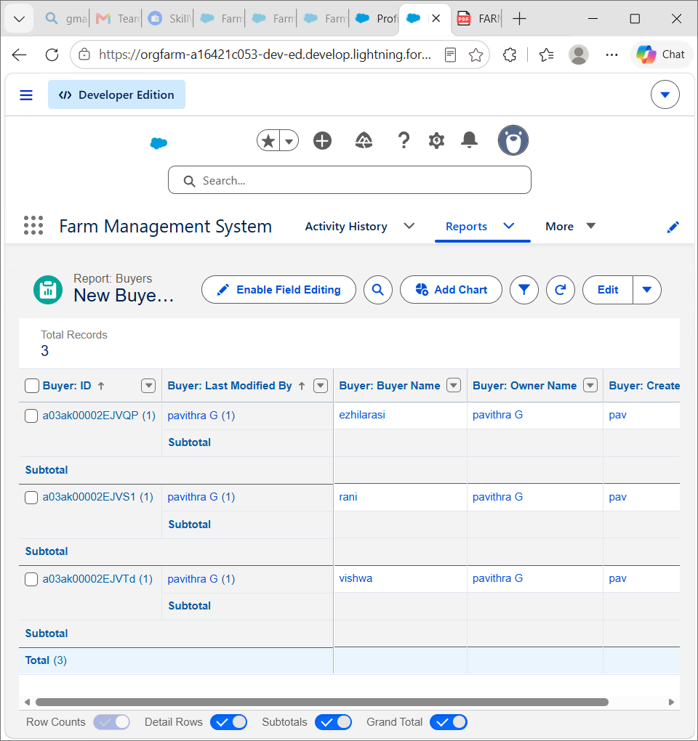
Milestone 12-Dashboard:

Dashboards provide more insights than reports as they combine the data from many reports and show a summarized result. Looking at many reports at a time gives the flexibility of combining the results from them quickly. Also summaries in dashboards help us decide on action plans quicker. The dashboards can contain charts, graphs and Tabular data.

Activity 1:
Create a Dashboard:
- Click the Dashboard tab.
- Click New Dashboard.
- Name the dashboard Farmers with farms and click Create.
- Click +Component.
- Select the Farmers with Farms and click Select.
- Select the Gauge chart and click Add.
- Click Save and then Done.

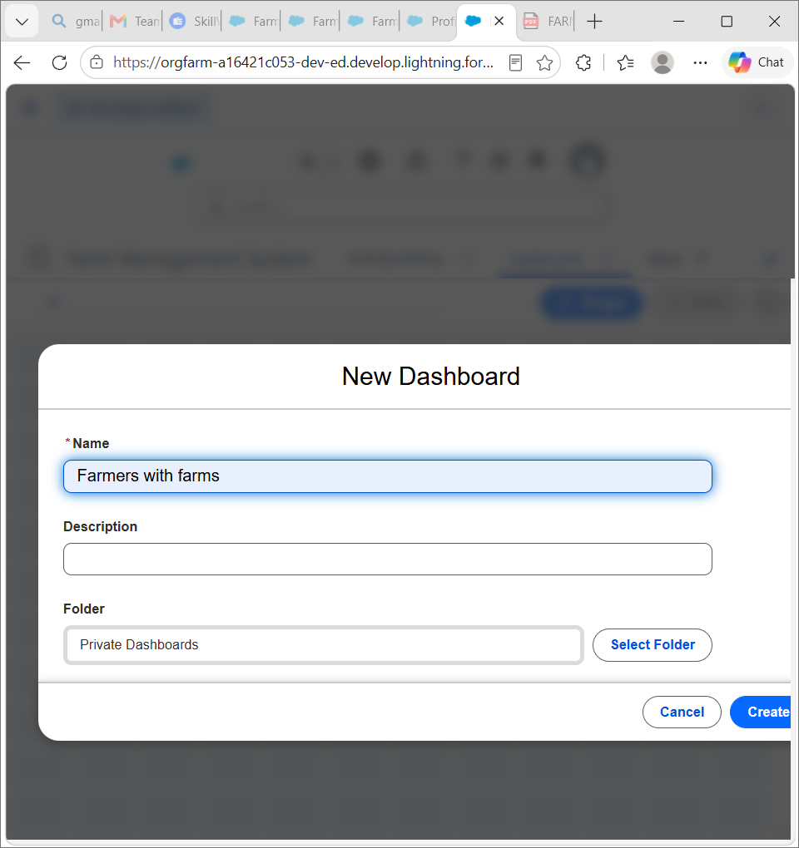
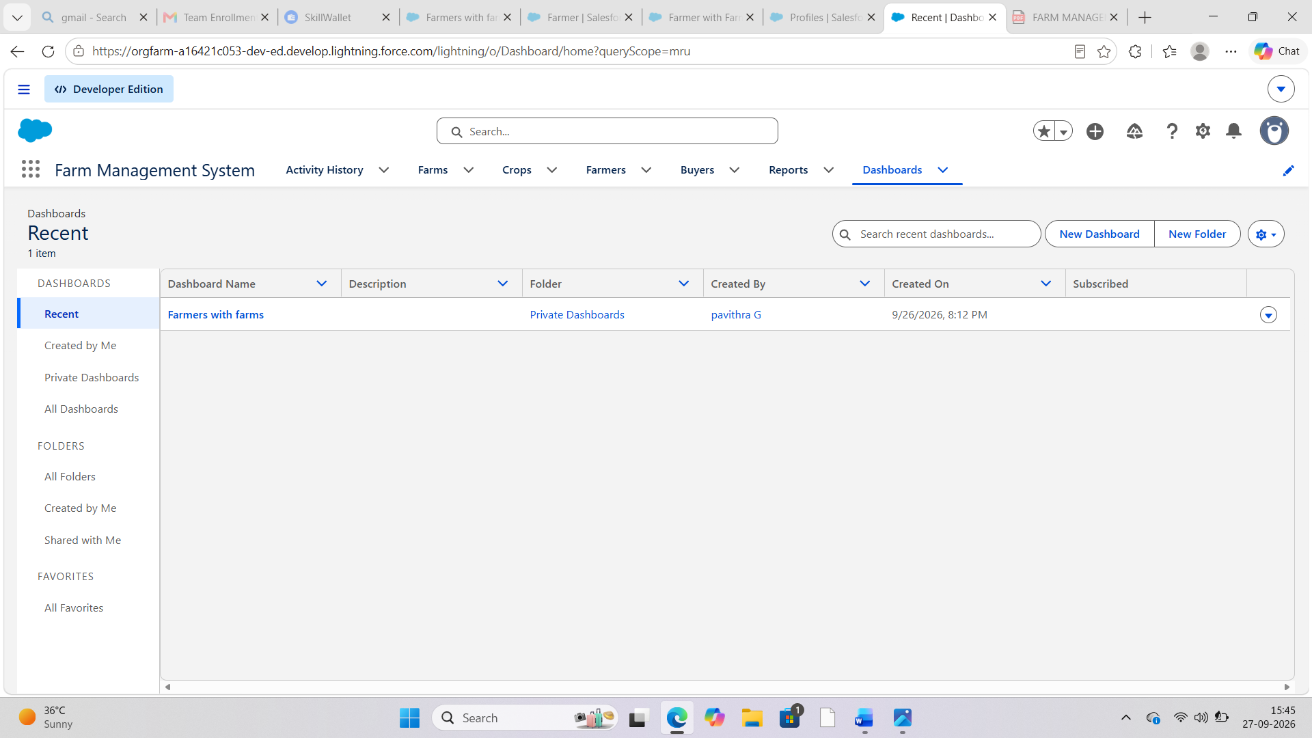
Milestone-13: View Report and Dashboard:

Activity 1: Report
- Click on App Launcher on left side of screen.
- Search Farm Management System & click on it.
- Click on Reports Tab.
- Click on Farmers with Farms & see records

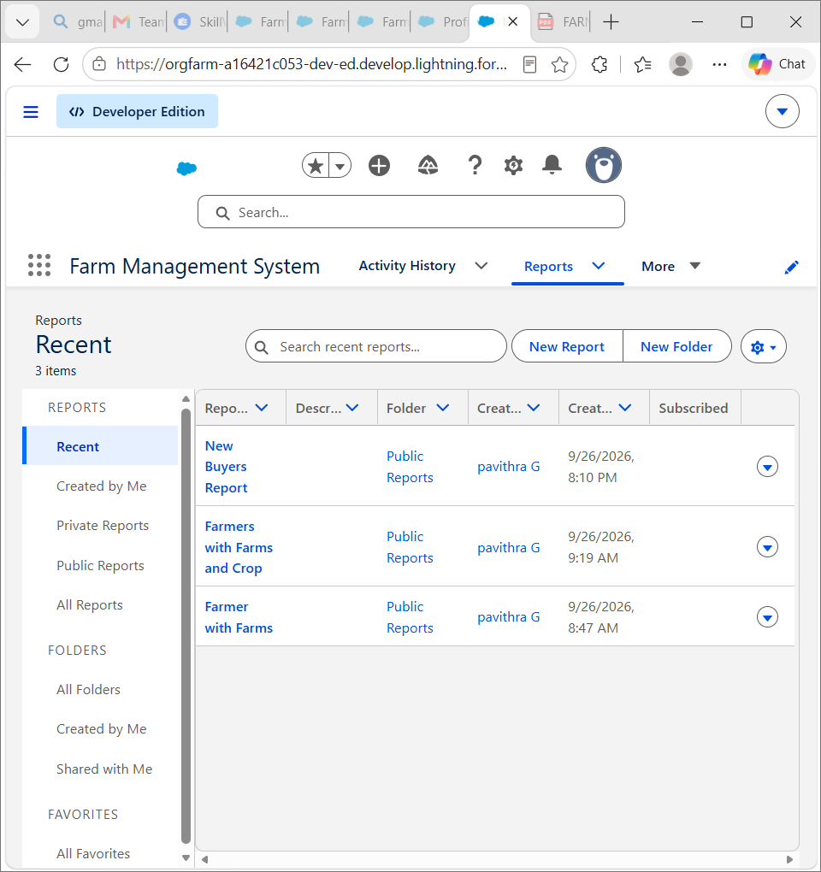
Activity 2: Dashboard

- Click on App Launcher on left side of screen.
- Search Farm Management system & click on it.
- Click on Dashboard Tab.
- Click Farmers With farms & see records.

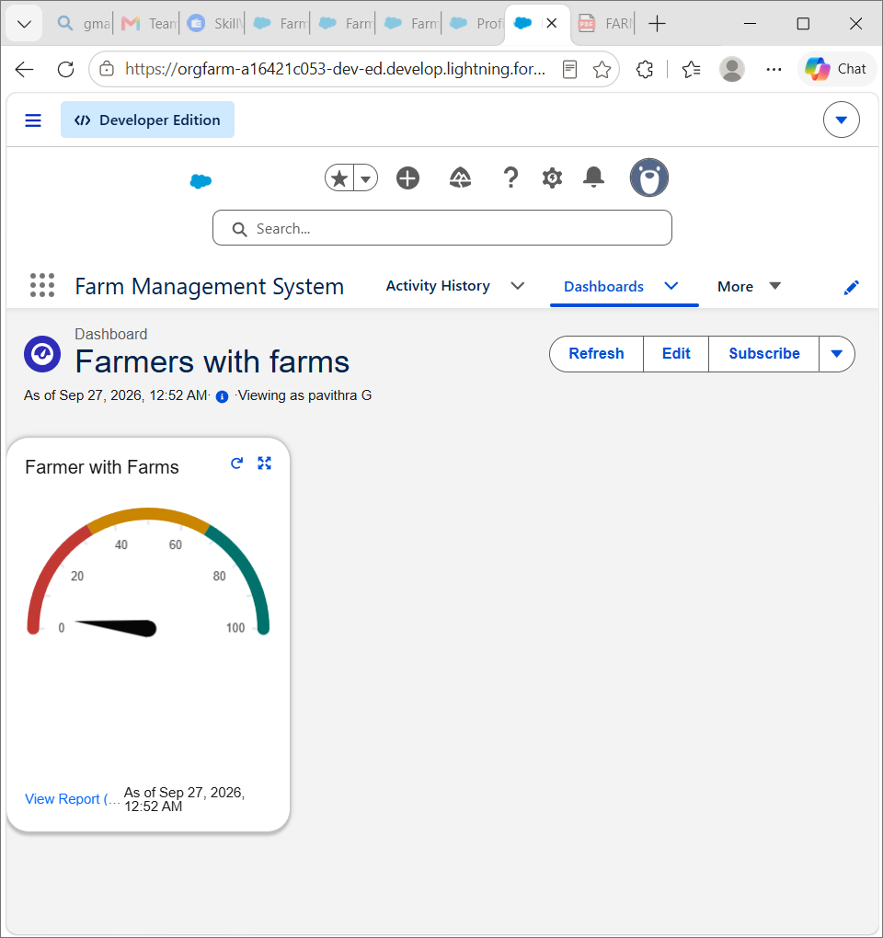

7. FUNCTIONAL & PERFORMANCE TESTING

During the testing phase, screenshots were captured from the Salesforce interface to verify system functionality. The following were tested:
- Creation of Farm, Crop, Farmer, and Buyer records
- Validation of input fields
- Relationship and dependency checks
- Profile and role access testing
- Sharing rule verification
- Report and dashboard generation
Performance testing ensured smooth system response and stability during multiple user operations. 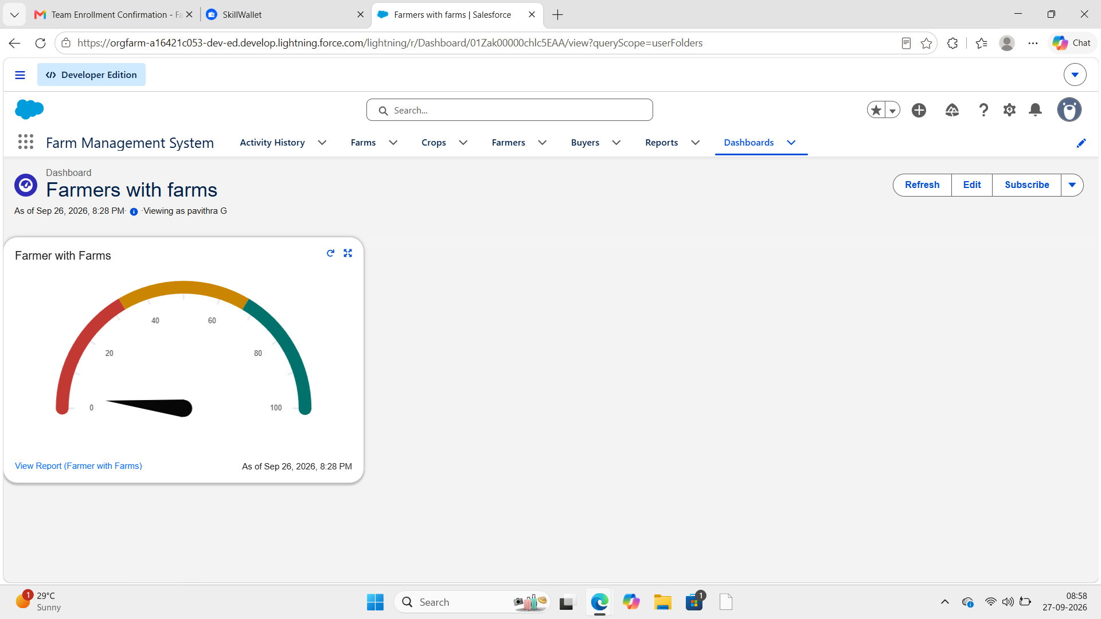

8. ADVANTAGES & DISADVANTAGES

Advantages
- Centralized Data Management – Farmer, crop, and buyer information can be stored in one place.
- Easy Access to Information – Users can quickly view and update farm-related records.
- Reduced Manual Work – Reduces the need for maintaining multiple paper-based records.
- Better Data Organization – Farm information is maintained in a structured format.
- Reports and Visualization – Reports and charts help users understand and monitor the available data.
- Improved Efficiency – Makes managing farmer, crop, and buyer records faster and more organized.
- Future Scalability – The system can be extended with additional agricultural features in the future.

Disadvantages
- Internet Dependency – As a cloud-based system, access may depend on a stable internet connection.
- Initial Learning Requirement – New users may need some time to understand the system and its features.
- Data Entry Required – Accurate information must be entered and updated regularly by users.
- Limited Current Features – The present system mainly focuses on farmer, crop, and buyer management.
- Maintenance Required – The system requires regular maintenance and updates to keep it useful and reliable.

9. Conclusion:

The Farm Management System provides a centralized and organized platform for managing important farm-related information. The system helps maintain farmer, crop, and buyer records in a structured manner and makes the information easier to access and manage.
By reducing dependence on scattered or manual records, the system improves data organization and management efficiency. Reports and data visualization further help users monitor the available information effectively. The project also provides a foundation for future enhancements such as weather updates, crop recommendations, notifications, and advanced agricultural analysis.

10. FUTURE SCOPE
- Mobile application integration
- AI-based crop prediction
- Weather data integration
- IoT sensor connectivity
- Government scheme integration
- Market price forecasting

11. APPENDIX
- Source Code: Salesforce Configuration and Metadata
- Dataset: Farm, Crop, Farmer, and Buyer Records
- Tools Used: Salesforce Developer Org

Thank You

